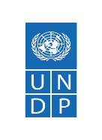Global Fund PMU 2023 Annual
Report
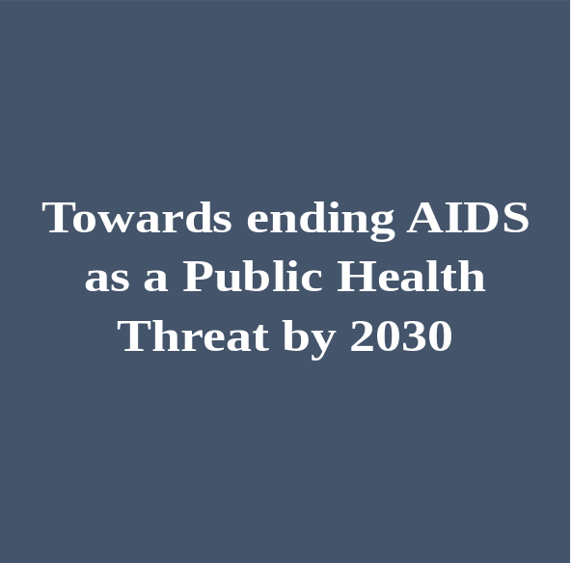

NFM3 GF HIV Grant Profile

Project Title: Towards ending AIDS as a Public Health Threat by 2030

Grant Number: ZIM-H-UNDP
Disease: HIV/AIDS
Country: Republic of Zimbabwe

Project Start Date: 01st Jan 2021
Project End Date: 31st Dec 2023
Total Approved Budget: $481,540,897

Principal Recipient: United Nations Development Programme - UNDP
Sub-Recipients:
- National AIDS Council (NAC)
- Ministry of Health and Childcare (MoHCC)
- National Pharmaceutical Company of Zimbabwe (NATPHARM)
- Health Services Board (HSB)
- World Food Programme (WFP)
- Medicines Control Authority of Zimbabwe (MCAZ)
- Family AIDS Caring Trust (FACT)
- Biomedical Research and Training Institute (BRTI)

```
Table of Contents

List of Tables and Figures iv
List of Acronyms v
Executive Summary vi
1. Introduction 1
2. Project Overview 3
1.3 Project Goal & Objectives 3
1.4 Partner Roles and Responsibilities 4
3. Implementation of New Funding Mechanism 3 (NFM3) HIV Grant 7
4. Results for HIV Grant key performance indicators and AWP targets 9
4.1 HIV Grant Overall Performance Rating 9
4.2 Financial Performance 10
4.3 NFM3 HIV Main Grant Financials 11
4.4 Asset Management 12
5. Key Programmatic Interventions 13
5.1 Impact/Outcome Indicators 13
5.2 Coverage Indicators 14
5.2.1 Prevention of Mother to Child Transmission (PMTCT) 14
5.2.2 HIV Prevention, Treatment, Care and Support Services 16
5.2.3 Adolescent Men, Girls and Young Women Programme 20
5.2.4 Key Population Programmes 23
5.2.5 Performance of RSSH indicators 27
6. HIV and Development 31
7. Covid 19 Response Portfolio optimization Wave 2 32
8. Infrastructure activities/Solar Systems 32
9. Procurement and Supply Chain Management 34
10. Monitoring and Evaluation 37
11. Communications 40
12. Key Challenges 44
13. Success Stories 45
14. Annex 1 Key Performance Indicators 46

List of Tables and Figures
Table 1 HIV Grant SRs with Roles and Responsibilities 2023 4
Table 2 NFM3 Capacity Development approved Budget and expenditures by SRs 8
Table 3 Financial performance Update as of 31 December 2023 10
Table 4 Summary of NFM 3 HIV grant Approved cumulative Budget & Expenditures by Cost Grouping 2023 11
Table 5 Summary of NFM3 HIV Grant Cumulative Approved Budget & Expenditures by Sub-Recipient 2021-2023 11
Table 6 Summary of assets transferred by SR (in value and category) 2023. 12
Table 7 Performance of RSSH Indicators 2023 27

Figure 1 2021-2023 implementation arrangement of the HIV NFM3 grant 5
Figure 2 Trends in HIV Grant Performance Rating 2018- June 2023 9
Figure 3 Trends in PMTCT Coverage 2018-2023 14
Figure 4 HIV Exposed infants receiving a virological test for HIV within 2 months of birth 15
Figure 5 Adults who are currently on ART at the end of December 2023. 17
Figure 6 Coverage performance of children (under 15) 2023 18
Figure 7 Trends in ART Uptake 2023 18
Figure 8 Trends in HTS and Positivity, 2023 19
Figure 9 S2S program performance 20
Figure 10 Education Subsidies 21
Figure 11 Performance of Sew Work Programme indicators 23
Figure 12 Number of attritions by category of staff 2023. 29
Figure 13 Implementation of Integrated Sample Transportation (IST) 2023 30
Table 14 Installed S4H and Borehole systems per province December 2023 33

List of Acronyms
ART | Anti–Retroviral Therapy
ARVs | Anti-Retroviral Drugs
CBOs | Community Based Organizations
CCM | Country Coordinating Mechanism
CDC | Centre for Disease Control
CHBC | Community Home Based Care
DFID | British Department for International Development
DREAMS  ETA  GBV  GFATM | Determined Resilient Empowered AIDS-Free Mentored & Safe  Expected Time of Arrival  Gender Based Violence  Global Fund to Fight AIDS, Tuberculosis and Malaria
GF CT  GoZ  HIV | Global Fund Country Team  Government of Zimbabwe  Human Immune Deficiency Virus
ICT  IP  LFA | Information Communication Technology  Implementing Partner  Local Fund Agent
MCAZ  M & E | Medicine Control Authority of Zimbabwe  Monitoring and Evaluation
MOHCC | Ministry of Health and Childcare
NAC | National AIDS Council
NATF | National AIDS Trust Fund
NFM  NatPharm  PCC | New Funding Model  National Pharmaceutical  Primary Care Counsellors
NGO | Non-Governmental Organization
OSC  PFMS  PLHIV | One Stop Centre  Public Finance Management System  People Living With HIV
PR | Principal Recipient
PSI | Population Services International – Zimbabwe
PSM | Procurement and Supply Management
SASA  SR | Start Awareness Support Action  Sub-Recipient
SSR | Sub-Sub-Recipient
S4H  TB | Solar For Health  Tuberculosis
`UNDP | United Nations Development Programme
UPS  USAID | Uninterrupted Power Supply  United States Agency for International Development
VHW  WHO | Village Health Worker  World Health Organization
ZACH | Zimbabwe Association of Church-related Hospitals
ZAN | Zimbabwe AIDS Network
ZimStat | Zimbabwe Statistical Agency
ZINQAP | Zimbabwe Quality Assurance Programme
ZNFPC | Zimbabwe National Family Planning Council

Executive Summary
UNDP has partnered with the Global Fund (GF) to Fight HIV/AIDS, Tuberculosis and Malaria in Zimbabwe since 2009. During New Funding Mechanism 3 (NFM3), UNDP continued to serve as PR for the HIV grant and Fund Administrator (FA) for the TB and Malaria grants, which the Ministry of Health and Childcare was the Malaria and TB PR for the three years grant period (2021-2023).
Despite the severity of the HIV/AIDS epidemic, its transmission and prevalence in Zimbabwe has been on the decline, this has been demonstrated through the steady decline in the number of AIDS related deaths per 100,000 population from 319/100,000 in 2016; 109.2/100,000 in 2017; 130.9 /100,000 in 2018; 141.5/100,000 in 2020; 164/100,000 in 2021 and dropped to 120.7 in 2022. As of the end of December 2023, 1,233,934 of the targeted adults and children with HIV infection were reported to have received antiretroviral therapy. The performance of adults (15 and above) on ART among all adults living with HIV at the end of the reporting period was 96.27% (1,189,793/1,235,851) which is comparable to 96.16% (1,182,126/1,229,314) achieved at the end of December 2022. The 2023 reported results showed an achievement ratio of 102% PLHIV on ART as compared to 103% in 2022. The performance of indicator children (under 15) on ART among all children living with HIV at the end of the reporting period was 59.18% (44,141/74,587) which shows 12.25% points decrease when compared to 71.43% (51,493/72,088) achieved at the end of December 2022. The achievement ratio was 76% in 2023 as compared to 94.69% (71.40%/75.40%) attained at the end of December 2022 showing 19.01% points decrease. The performance of percentage of HIV-positive women who received ART during pregnancy and/or labour and delivery was at 81.5% (42,266/51,057) against a set target of 95% which resulted in an achievement ratio of 85.8%. as compared to 85.5% achievement ratio in 2022. Percentage of HIV-exposed infants receiving a virological test for HIV within 2 months of birth was 96.38% (49,972/51,846) against the target of 85% (47,218/55,552). This was a 22.7% performance increase as compared 89% 47,935/53,744 achieved in 2022. The achievement ratio in 2023 was 113 which is 2.5%-point decrease as compared to an achievement ratio of 115.5% for 2022.
In 2023, ppercentage of PLHIV on ART who initiated TB preventive therapy among those eligible during the reporting period was 68.7% (221,381/322,277) against a set target of 80% resulting in an achievement ratio of 85.9% as compared to 2022 achievement ratio of 58%. This shows an achievement ratio increase by 31.9%. The performance of HIV-positive results among the total HIV tests performed during the reporting period is 4.9% (77,695/1,571,619) against set target of 5% for 2023.
In 2023 reporting period, 96.1% of targeted health facilities providing diagnostic services that had tracer item (determine) and, 99.9% of targeted health facilities providing had tracer medicines (TLD90 and TLD 30) and 83% targeted health product batches for the HIV were tested for quality in line with Global Fund Quality Assurance policy. Completeness of facility reporting was 108.3% and total posts that had been vacant for the past six months were 6.8% against a set annual target of 6% for the reporting period an improvement from the 13% attrition in 2022.
The project managed to reach 47,322 people (24,519 AGYW and 22,803 ABYM) against a target of 44,777 this was a total reach of 106% as compared to 2022 achievement ratio of 107%. Ninety percent of the girls assessed HTS services which is an increase by 7% as compared to 83% reported in 2022.
The Sista2Sista program reached 99.2% (14,855/14,970) against the set target of 100% (15,00/15,000) and resulted in an achievement ratio of 99%. The achievement ratio is comparable to 98% achieved as of Dec 2022. During the reporting period, 77% (34.633/45,000) Sex Workers (SWs) were reached with the minimum package as compared to the set target of 56% which resulted in an achievement ratio of 137%. Furthermore, 33.5% (8,714/26,010) eligible SWs were initiated on PrEP as compared to the set target of 50% (5,770/26,000) which resulted in an achievement ratio of 67%; and 147.2% (38,298) SWs received an HIV test and know their results as compared to the set target of 60%. About 48.1% (11,229/23,326) MSMs were reached with the minimum package against the set target of 38% which resulted in an achievement ratio of 126.7%; of the MSM reached with the minimum package 13.4% (2,460/18,404) received an HIV test during the reporting period and know their results as compared to the set target of 17% which resulted in an achievement ratio of 76%. For those MSM eligible for PrEP 8% (1,478/18,404) received PrEP as compared to the set target of 18% which resulted in an achievement ratio of 44.6%.
The total actual cumulative expenditure for 2021-2023 was USD416,250,559.64 against an approved budget of USD481,541,897.00, representing an in-country absorption rate of 97%. UNDP facilitated disbursements to the MOHCC for TB (2), Covid19 Malaria and Malaria (3) grants and provided support for all health and non-health procurements. UNDP conducted spot check to 74% of the aggregate expenditures reported by the MOHCC 9% higher than the 65% expenditure requirements.
The key challenges programmatic performance during the 2023 were low performance of MSMs tested for HIV, high staff turnover, data quality issue, delay in completion of infrastructure projects, lack of sustainability plan for S4H and infrastructure projects.

Introduction

UNDP has partnered with the Global Fund (GF) to Fight HIV/AIDS, Tuberculosis and Malaria in responding to and accelerating progress towards ending the three epidemics. UNDP assumed the Principal Recipient (PR) of the Global Fund Grants (HIV, Malaria, TB and HSS) in Zimbabwe since 2009. Following a new implementation arrangement in 2015, UNDP continued to serve as PR for the HIV grant and Fund Administrator (FA) for the TB and Malaria grants, which the Ministry of Health and Childcare is the PR.
The Global Fund for HIV, TB, and Malaria (GFATM) New Funding Mechanism 3 (NFM3) HIV Grant started in January 2021 following the finalization of grant negotiation and Grant Confirmation in Q4 of 2020. The project covered a period of three years 2021-2023, and it aimed to consolidate gains made in the national response towards ending AIDS as a Public Health Threat in Zimbabwe by 2030. UNDP provided Grant Fund Administration (GFA) support services to the MoHCC, the PR for the TB and Malaria grants. The activities of the 2023 PMU were guided by the PMU annual workplan and the project Detailed Implementation Plan (DIP). The approved 2023 PMU workplan and field visit plan were implemented in line with UNDP/GF guidelines and the grant agreement ZWE-H-UNDP.
This report covers the implementation period for the final year of the NFM3 grant (January - December 2023) where UNDP served as a PR for the HIV grant and GFA for the TB and Malaria grants. It also provides results for the 2023 Health HIV and Development Interventions carried out during the same period.

  - Country Context

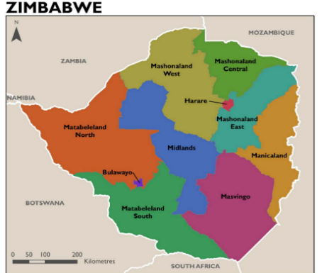
Zimbabwe is a landlocked country with a surface area of 390,757 square kilometres. and surrounded by Zambia to the north, South Africa to the south, Mozambique to the east and Botswana to the West. The Population of Zimbabwe in 2023 was projected at 15,178,957 with women accounting for 52% or 7,891,035 and men 48% or 7,287,922, using an annual growth rate of 1.48% (Zimbabwe 2023 Population Census Report, ZimStat). This gives a sex ratio of 92 males for every 100 females. Given the 2012 population size of 13,061,329, this gives an annual population growth rate of 1.5 percent. The population density of Zimbabwe is 39 people per square kilometers, which ranks 142nd in the world. Most of the population lives in rural areas (67%) while (33%) lives in urban areas (ZimStat, 2012). The population is relatively young with 41 percent of the population being below age 15 years, 55% between 15-64 years and about 4 percentage 65 years and above (ZimStat 2023).

The maternal mortality ratio is estimated at 363 per 100,000 live births; and under-five mortality at 39.8 deaths per 1,000 live births (Census 2022), both reduction form 2019 estimates. The neonatal mortality rate has remained static at 31 deaths per 1,000 live births (MICS, 2019). Health service coverage, particularly in remote and urban poor areas remains low due to weak and underfunded health systems and insufficient human resources, impact of health outbreaks, harmful social norms, including religious beliefs and practices that exclude women and girls.

An estimated 1.3 million people (about the population of New Hampshire) of the population were living with HIV (PLHIV) in 2022; adults (15+) account for 94.3% or 1.23 million women constituted an estimated 60.8% (751,700) of all adults aged 15+; and children under 15 years of age 5.7% or 74,500 of all people living with HIV (2023 HIV Estimate Report). Between 2018 and 2023, adult (15-49) HIV prevalence rate has declined from 13.11% to 11.01%. In 2022, approximately 51,800 HIV positive pregnant women required PMTCT services. HIV incidence rates among adults aged 15 - 49 declined by over 84% from 1.08% in 2010 to 0.17% in 2022.

Tremendous progress has been made in the National HIV Response and Zimbabwe is largely on track to achieve the ZNASP IV extended prevention, care and treatment targets by 2026. Annual AIDS related deaths have declined by 64% in 2022 from 56,900 in 2010 to 20,400 in 2022. All age groups recorded a decreasing trend in AIDS related deaths over time and this was as a result of a comprehensive ART program. In 2022, an estimated 40,500 deaths were averted by ART in both adults and children. Harare recorded the most AIDS-related deaths followed by Midlands, while Bulawayo Province recorded the least followed by Matabeleland North. With fewer new HIV infections than AIDS deaths, the country has achieved epidemic control.

There were about 17.3 thousand new infections in 2022. There were approximately 13,000 new HIV infections that occurred among adults and 4,200 among children in 2022. Matabeleland South (2.7) had the highest incidence rate per 1000 uninfected population while Mashonaland Central had the least (0.7). HIV incidence rates among adults aged 15 - 49 declined by over 84% from 1.08% in 2010 to 0.17% in 2022, due to the scale up of various HIV prevention and treatment programmes. There was a decline in New HIV infections for all age groups; the number of new HIV infections among adults declined by 7% and among children also reduced by 9% from 2021 to 2022. The number of new HIV infections among 10-19 years declined by 6% whilst among 15-24 years reduced by 7% from 2021 to 2022. In 2022, the incidence rate was highest in Matabeleland South while most new infections were recorded in Midlands.

Worryingly, the mother-to-child transmission rate has increased in Zimbabwe since the last funding request, from 7.6% in 2019 to 8.1% in 2022. The number of mothers receiving prevention of mother-to-child services declined from 57,753 in 2019 (94% of those in need) to 43,856 in 2022 (85% of those in need). The Mother-to-child HIV transmission, which accounts for more than 90% of new childhood infections, can be reduced to less than 5% by providing an HIV-positive mother access to effective antiretroviral therapy (ART). The need for PMTCT continues to decline from 91,081 to 51,845 in 2000 and 2022 respectively. Adolescent Girls and Young Women (AGYW) contributed 23% of the Need for PMTCT at national level whilst Mashonaland Central, Harare, Manicaland, Mashonaland west, Matabeleland South, contributed 24%, 24%,24%,25%,26% respectively. In 2022, the PMTCT coverage was 85% and it varied by province with Harare (100%), Bulawayo (100%) and Mashonaland West (99%) meeting the validation process target of <=95%. In 2022, 4200 new paediatric infections were realized, which translates to the mother to child transmission rate including breastfeeding period of 8.1% (2023 HIV Estimates report).

Most new infections were coming from pregnant and lactating women who were not put on ART. They contributed 1,495 new infections during pregnancy and 563 new infections during the lactating period. The other contributor to HIV new infections in children were women who were not retained on ART during the pregnancy and breastfeeding period contributing a total of 836 new infections. Incident infections are also contributing to a significant number of new infections in children causing a total of 613 infections. The PMTCT programme continues to avert more new HIV infections amongst children, with 10,771 have been averted in 2022 compared to 245 in 2003.

The highest rates of new infections in Zimbabwe are among AGYW, peaking among 20-24-year-olds, followed by 15-19-year-olds. Incidence among adolescent girls is about 8 times that of their male peers. New infections among AGYW are aggravated by limited HIV knowledge (46.3% among 15-24-year-olds) , high rates of teenage pregnancy (24% among 15-19-year-olds), child marriages (13% nationally, and 27.4% in rural areas, among 15-19-year-olds) , sexual violence (32.5% among 18-24-year-olds before 18 years), age of consent for services (16 years) and low school attendance (21.4% out of school).

National HIV prevention cascades reveal that less than half of girls at-risk are reached with comprehensive sexuality education (CSE) in school, and a quarter of those are referred to HIV and sexual and reproductive health (SRH) services, but provinces vary. In Bulawayo, CSE coverage is high, but service referrals are low. In Midlands, coverage of CSE is lower but most of those reached are referred to services. For young women, most colleges (85%) have HIV testing facilities on campus, but confidentiality is a gap.

Although Zimbabwe has surpassed the 95:95:95 UNAIDS targets with 95 per cent of people living with HIV knowing their status, over 95 per cent of these being on anti-retroviral therapy (ART), and 95 per cent on ART being virally suppressed, some Key populations are still being left behind. ART coverage amongst children 0-14 years and adolescents 10-19 years, lags behind adults at 61 and 75 per cent, respectively due to failure to locate children and AIDS-related stigma. ART coverage amongst pregnant women living with HIV also lags at 86 per cent. Vertical transmission of HIV remained high at 8.1 per cent against WHO target of under 5 per cent, as not all pregnant women are accessing antenatal services which include HIV testing and treatment. This has led to the assertion that there needs to be further meaningful gains, efforts and resources must be oriented towards these groups and geographical areas.

Project Overview
  - The New Funding Mechanism 3 (NFM3) HIV Grant

The current NFM3 HIV grant was designed to focus Towards ending AIDS as a Public Health Threat by 2030. The project was aligned with, the National Health Strategy (2021-2025). The Country’s Health Sector Strategic focus was guided by the overall Vision 2030 that seeks to transform Zimbabwe into a middle income economy by 2030 and the National Development Strategy 1: 2021-2025 (NDS1). The National Development Strategy 1 [2021-2025] identified health as being central to human happiness and well-being making it an important contributor to economic progress, as healthy populations live longer, are more productive, and save more. The National Health Strategy (NHS) 2021-2025’s vision is to ensure the highest possible level of health and quality of life for all citizens of Zimbabwe by 2030 and this is anchored on the NDS1 [2021-2025]. In addition, the Zimbabwe HIV and AIDS Strategic Plan, ZNASP IV (2021-2025) was aligned with the National Development Strategy 1 (NDS 1 2021-2025). Hence grant activities were meant to commit the country “Towards ending AIDS as a Public Health Threat by 2030” “and Ending AIDS by 2030”.

Project Goal & Objectives
Goal: The set goals for the NFM3 grant are, a) Zero new infections by 2030 b) Zero AIDS related deaths by 2030 and 3) Zero HIV related discrimination by 2030. These were set to attain improved wellbeing and healthy lives for all population groups through universal access to HIV prevention, treatment, care, and support services.

Objectives:
The following are the specific objectives of the GF NFM3 HIV grant.
- 95% of people living with HIV who know their status are on ART and 95% of those on ART are virally suppressed by 2025.
- 95% of people living with HIV know their status and all vulnerable and key populations have access to HIV testing services.
- At least 90% of the key populations receive a defined package of HIV services.
- At least 90% of AGYW receive a defined package of HIV and SRH services by 2025.
- To achieve and sustain elimination of mother to child transmission of HIV and syphilis by 2025.
- To increase condom, use among high-risk males and females during risky sexual encounters to at least 90% by 2025.
- 80% male circumcision coverage attained in all districts by 2025.
- Effective STI diagnosis, prevention and management for the general population, people living with HIV and key populations.
- To reduce TB related deaths among people living with HIV by 80% by 2025
- Improved effectiveness of coordination structures and processes to contribute to attainment of ZNASP IV results.
- At least 30% of services being community-led by 2025.
- Make available quality data and strategic information to inform policy, programming, and service delivery at national and district levels.

Partner Roles and Responsibilities

HIV grant is implementing activities using eight Sub Recipients (SRs). The list of SRs and their roles and responsibilities is indicated in the table below.

Table 1 HIV Grant SRs with Roles and Responsibilities 2023

 | Partner | Roles and Responsibilities
1. | UNDP – The Principal Recipient (PR) | UNDP as PR is responsible for programme and financial management, procurement, M&E and reporting of the grant approved activities. With a dedicated Program Management Unit (PMU), UNDP oversees the implementation and effective use of the grant funds and reduce the overall risk, supports the flow of funds into the country and strengthens the capacity of the national implementing partners for improved delivery of program activities.
2. | Ministry of Health and Childcare (MoHCC) | MoHCC is a government ministry that promotes the health and quality of life of the people of Zimbabwe. Under the grant, MoHCC is responsible for implementing several program components including: HIV Testing and Counselling; Treatment, Care and Support; TB/HIV collaborative interventions; PMTCT - Preventing vertical HIV transmission, Treatment, Care and support to mothers living with HIV and their children and families; Program Management (HIV)- Planning, Coordination and management and staff salaries; M&E (HIV), Managing Health Information Systems ePMS/DHIS2; Routine reporting, Analysis, Surveys and several others.
3. | National AIDS Council (NAC) | NAC is an organization enacted through the Act of Parliament of 1999 to coordinate and facilitate the national multi-sectorial response to HIV and AIDS. It is also mandated to administer the National AIDS Trust Fund (NATF) collected through the AIDS Levy i.e. the 3% collected from every worker’s taxable income (PAYE) and corporate tax. Under the current grant, NAC is responsible for coordinating: (i) Adolescent Girls and Young Women (ii) Key Populations. The SSRs under NAC include Plan International, ZACH, CeSHHAR and UNFPA.
4. | Medicines Control Authority of Zimbabwe (MCAZ) | MCAZ is an autonomous body whose mandate is to ensure the manufacture, sale, distribution, and use of safe, efficacious, and good quality medicines. Under the Grant, MCAZ is responsible for implementing quality control and quality assurance including pharmacovigilance for pharmaceuticals and health commodities.
5. | Health Services Board (HSB) | HSB is a parastatal organization with the mandate to appoint persons to offices, posts and grades in the Health Services; to create grades in the Health Services and fix conditions of services for its members; to supervise and monitor health policy, planning and public health; to enquire into and deal with complaints made by members of the Health Services; to supervise, advise and monitor the technical performance of hospital management boards and state aided hospitals; Under the current grant, HSB is responsible to manage the payment of allowances as part of efforts to reverse the trend of high outward migration and ensuring that the number of health professionals entering the public health system from clinical schools is larger than the numbers leaving the health sector.
6. | NatPharm | NatPharm is a parastatal under the Ministry of Health and Childcare, which is responsible for the storage and distribution of health commodities. Under the grant, NatPharm is responsible for storage and distribution of pharmaceuticals and health commodities procured by grant funds. NatPharm has six warehouses nationwide whose storage capacity is approximately 12, 812 sqm and a complement of about 32x7-9 Tonne Delivery trucks for distribution.
7. | World Food Programme (WFP) | Under the grant reporting period WFP provided logistic support and storage services especially for non-health, products.
8 | Biomedical Research and Training Institute (BRTI) | BRTI is implementing the Integrated Specimen Transportation (IST) programme as the SR for this project on behalf of the Ministry of Health & Childcare (MOHCC).
9 | Family AIDS Caring Trust (FACT) | FACT is responsible for implementing community led activities under the grant

In addition to working with the SRs to deliver on the grant, UNDP has been working in close coordination with UN agencies through the UN Health cluster and through the Health Development Partners Group with bilateral and other multilateral donors, such as World Bank, EU, etc. UNDP is working in collaboration with UNAIDS, WHO, PEPFAR and other partners working in HIV.

Figure 1 2021-2023 implementation arrangement of the HIV NFM3 grant

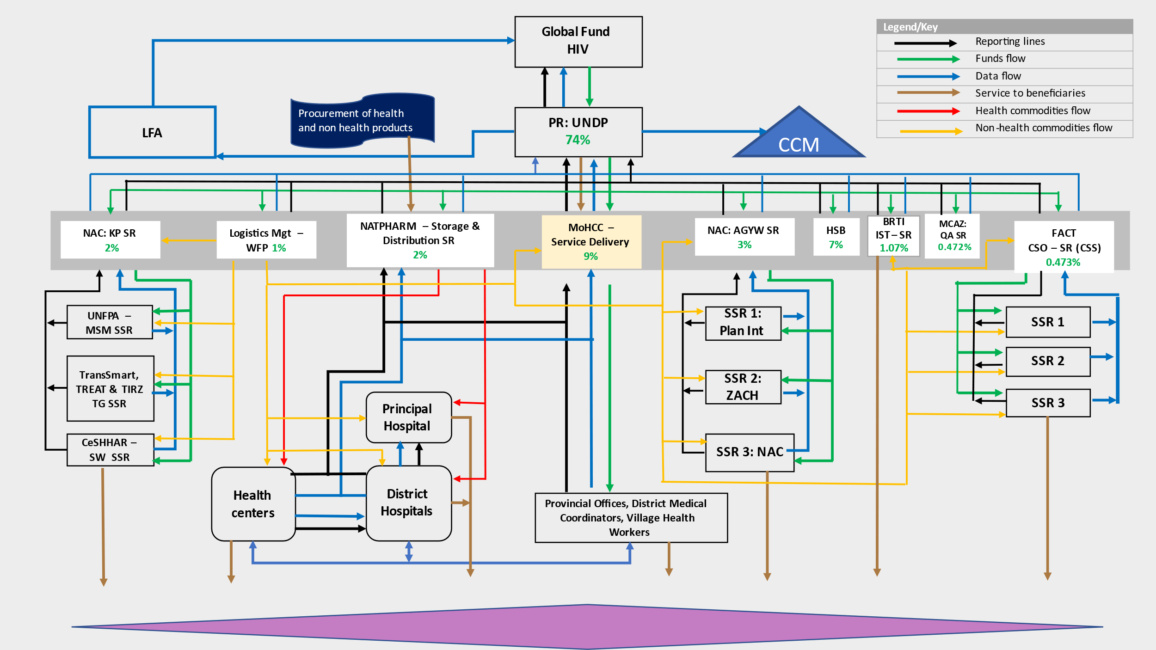

The SRs are working with Sub-Sub Recipients (SSRs) and there are five sub-sub-Recipients under the AGYW and Key Populations programs under NAC SR-ship. These include:

- Plan International – responsible for the DREAMS/AGYW program.
- Zimbabwe Association of Church related Hospitals (ZACH) – responsible for the One-Stop-Center (OSC) and the Start Awareness Support and Action (SASA) Programs
- NAC Local Partners - for Sister-to-Sister programs, Trans Smart, TREAT, TIRZ - Comprehensive prevention programmes for Transgender
- Centre for Sexual Health and HIV/AIDS Research (CeSHHAR)– responsible for implementation of HIV programme for Sex Works and their clients
- UNFPA (SRC & GALZ) – responsible for implementation of HIV programme for Men having Sex with Men (MSM)

  - Operating Environment

The operating environment in Zimbabwe remained challenging during the reporting period (January – December 2023). Prior to and following the effects from COVID-19, Zimbabwe faced challenges with regards to macroeconomic stability, characterized by high inflation and volatile exchange rates, and persistent shortages of electricity, constricting economic performance with agriculture in addition to climate change impact. The economy slowed from a Real Gross Domestic Product growth rate of 6.5 (2022) to 5.5 (2023) per cent and projected to 3.5 per cent in 2024 according to the Ministry of Finance, Economic Development, and Investment Promotion. The exchange rate depreciated by more than 600 per cent and inflation averaged 104 per cent impacting the economy negatively, eroding purchasing power and limiting provision of social services, with increased burden on vulnerable households and children (Reserve Bank of Zimbabwe). The situation is worsened by climate-induced shocks, including floods and drought, exacerbated by economic instability, and public health emergencies of cholera, polio and measles. Overall Government spending on the social sector was at 30.4 per cent of the national budget. Health sector allocation was 11.2 per cent below the 15 per cent Abuja Declaration target. Education allocation was 14.9 per cent compared to 20 per cent Dakar framework for Action target; water, hygiene and sanitation (WASH) received 1.8 per cent and social protection was 4.2 per cent. Recent comprehensive data on health care costs and affordability of health care services are not readily available. It is important to note that these fluctuations in health care spending had a very limited impact on HIV, TB and Malaria programming, which relies almost exclusively on funding from the Global Fund to Fight AIDS, Tuberculosis and Malaria (Global Fund) and PMI. Various sources estimate that the percentage of Zimbabweans with private health insurance that could defray some of these household expenses is only approximately 10 percent. This low health insurance coverage rate also means that the more costly, and often higher quality, private health sector options are not affordable for majority of Zimbabweans.

The country completed the harmonized elections in August 2023 granting a second term to the administration. The Mid-Term Review of the National Development Strategy 1 (2021–2025) of the Government was completed, noting progress, reinforcing the commitment towards devolution to promote inclusive local governance and decentralized service delivery and outlining strategic shift towards the vision to achieve a middle-income country status by 2030.

Implementation of New Funding Mechanism 3 (NFM3) HIV Grant

UNDP as the Principal Recipient (PR) of HIV grant managed the implementation of various components of grant implementation that includes financial management, Procurement and Supply Management (PSM), programmatic management as well as monitoring and evaluation of all grant-financed activities during the second year of grant implementation. The second year expanded and consolidated the gains made during the first year which was mainly characterized by the grant signing between PR and Sub-Recipients.

  - Grant Fund Administration for TB and Malaria Grants

The initial implementation arrangement for the transitioning of the New Funding Model (NFM) TB and Malaria grants from UNDP to the Ministry of Health and Childcare (MoHCC) as Principal Recipient (PR) for the two grants resulted in Global Fund appointing UNDP to provide Fund Administrator (FA) Support Services to the MoHCC, from 2015 to 2017. Under the current Grant Cycle 6 (2021-2023), UNDP was again requested to provide similar support to the PR, MoHCC.
UNDP support services to MoHCC is to enable it to deliver the TB and Malaria grants. The FA role aims at mitigating the risk of loss of Grant Funds and ensure that effective risk management measures are in place with respect to the funds disbursed to the Principal Recipient and, where applicable, sub-recipients and sub-sub-recipients. In addition, UNDP provided assurances to ensure that the use of GF Funds is used in accordance with the approved Work Plan and Budget under the Grant Agreements and in compliance with the PR’s Administration, Financial, Procurement and Accounting Procedures Manual.
UNDP facilitated all disbursements to the Principal Recipient on the basis of its own risk assessment, in accordance with UNDP regulations, rules, policies and procedures. Quarterly disbursements were made to MoHCC provided that minimum requirements as clearly stipulated had been fully met by the Principal Recipient. On a quarterly basis, UNDP reviewed all disbursements made by the PRs to SRs and/or sub-sub-recipients (SSRs) and also verified that disbursements to sub-recipients and/or sub-sub-recipients were done in full compliance with the underlying rules and regulations of the grant. Specifically, UNDP under this arrangement provided support for all health and non-health procurement conducted by the Principal Recipient (other than those health products procured through the Global Fund’s Pooled Procurement Mechanism).
The spot checks for 2023 covered 74% of the aggregate expenditures reported by the PR for the period, which is 9% higher than the 65% expenditure requirements recommended to be sampled and verified per the TOR for the Support Services. In addition to the grant documents and MoHCC policies and guidelines, the verification was also guided by the current MoHCC Financial Management Standard Operating Procedures (SOP). UNDP assessed all procurements done by the Principal Recipient to ensure that they comply with all applicable standards and regulations.

  - Capacity Development plan
The 2022 to 2023 CD Plan has been designed to complete interventions planned to address capacity gaps during 2018-2020 that could not be implemented due to the COVID in 2020, the last year of grant implementation, but remain critical, and support further innovations in grants management processes to improve efficiency, reliability, resilience, and sustainability. Year 2023 continued to implement the CD Plan in an accelerated mode, to achieve results.
A total of 60 health workers from the MoHCC, MCAZ and NatPharm were enrolled in Empower Post Graduate Diploma in Procurement and Supply Chain Management and the completion date was 31 December 2023. The staff entails mainly pharmacists from the provinces and head offices. Of the 60 participants, 41 completed, 18 are at various stages of the course and 1 died. The course has been extended to 17 April 2024.
A total of 10 NAC staff enrolled in 2022 in the Chartered Institute of Procurement and Supply Chain (CIPs) programmes, all completed in 2023, and all passed the course. Procurement of IT equipment (Laptops, tablets and cameras) for ZACH, BRTI and Plan International was completed.
The main activities under the CD Plan were TA Support and a total of 41 TA support were developed and mainly focused on policies/guidelines/SOPs, skills development of SRs and their implementers on functional capacities, development of financial, and monitoring systems. A total of 38 consultants completed their tasks and 3 from the MoHCC could not complete and this was due to unavailability of the key staff, the restructuring of the MoHCC Senior Management and continuous breakdown of the MoHCC Server, which was required to facilitate the PFMs consultants.
The SR Capacity Assessment was successfully done, GC7 costed Capacity Development Plan was developed and was done with the support of consultants.
Table 2 NFM3 Capacity Development approved Budget and expenditures by SRs

Implementing Entity | Cumulative Budget | Cumulative Actual Expenditure | Cumulative Budget vs Actual Variance | Absorption Rate
BRTI | 8,000 | 3,274 | 4,726 | 41%
FACT | 24,500 | 19,461 | 5,039 | 79%
MCAZ | 10,000 | 9,510 | 490 | 95%
MOHCC | 486,093 | 296,144 | 189,949 | 61%
NAC and SSRs | 546,869 | 335,397 | 211,472 | 61%
UNDP Programme Management | 724,538 | 805,986 | - 81,448 | 111%
TOTAL CD | 1,800,000 | 1,469,771 | 330,229 | 82%

3.3 Regional HIV, Health, and Development Programme
UNDP’s #WeBelongAfrica Programme (#WBA) is a regional initiative that integrates two UNDP projects, namely the “Inclusive Governance Initiative” and the “Southern Africa Young Key Population Initiative”. #WBA is designed to support state entities in sub-Saharan Africa to become increasingly accountable and responsive to, and inclusive of, lesbian, gay, bisexual, transgender and intersex people (LGBTI) and Young Key Populations, which in turn will contribute to better laws, more responsive public-sector services, and social norms that affirm these populations’ perspectives, needs and rights. #WeBelongAfrica (WBA) is coordinated by UNDP’s Africa Region HIV, Health & Development (HHD) team.

  - CCM operation budget administration
In addition, UNDP is administered the operational budget on behalf of the CCM for a total amount of USD 200,000 for same period. The PMU processes HR salaries for the CCM Secretariat, positions, processes travel allowances for the CCM members doing field mission and procurement of stationery, workshops, communication (airtime and bundles), vehicle servicing, and office and equipment and supplies. The PMU supported and participated in the quarterly CCM field oversight and monitoring missions.

Results for HIV Grant key performance indicators and AWP targets

HIV Grant Overall Performance Rating

The last grant performance rating for Jan to June 2023 for programmatic rating was C- Moderate performance and good financial rating for period beginning implementation period, 1 January 2021 – 30 June 2022 was B1, and other ratings were all Cs for programmatic and Good for financial (July-December 2021, January to June 2022, July to Dec 2022, and January to June 2023).
The rating for semester (July to Dec 2023) was not yet received. The rating corresponds with programmatic indicator performance, financial reporting and any other related grant management issues during the period. The trend in grant performance Rating of the HIV grant for NFM3 semester 1 is shown in the Figure below.

Figure 2 Trends in HIV Grant Performance Rating 2018- June 2023

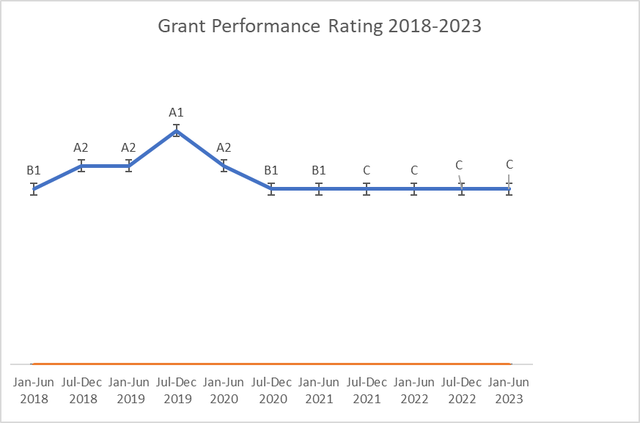

Financial Performance

UNDP implemented NFM3 for HIV, supported MOHCC in Fund administration for Malaria and TB, supported implementation of CCM activities and procurement of PPEs. The financial performance update as of 31 December 2023 is summarized as in the following table.
Table 3 Financial performance Update as of 31 December 2023

Disease Component | Grant Budget | Cumulative Expenditure | Commitments / Obligations as of 31 December 2023 | Total Incl. Commitments / Obligations | % Utilization (Budget Vs Exp)
HIV NFM3 | 481,541,897.00 | 416,250,559.64 | 51,413,117.14 | 467,663,676.78 | 97%
TB NFM3 | 14,619,247.00 | 13,071,088.38 | 28,781.75 | 13,099,870.13 | 90%
MALARIA NFM3 | 53,173,029.00 | 33,611,001.56 | 1,384,607.02 | 34,995,608.58 | 66%
CCM | 712,800.00 | 640,097.93 | 10,046.84 | 650,144.77 | 91%
WORLD BANK-CORDAID | 671,096.00 | 668,190.62 | - | 668,190.62 | 100%
TOTAL | 550,718,069.00 | 464,240,938.13 | 52,836,552.75 | 517,077,490.88 | 94%

NFM3 HIV Main Grant Financials
The total actual cumulative expenditure 2021-2023 was USD$467,663,676.78 against an approved budget of USD 481,541,897 representing an in-country absorption rate of 97%. The approved cumulative 2023 budget for C19RM was US$35,213,054 and expenditure of US14,449,679 (41%) was incurred during the period. The low expenditures relate to infrastructure activities and the low implementation of activities by SRs.
Table 4 Summary of NFM 3 HIV grant Approved cumulative Budget & Expenditures by Cost Grouping 2023

Cost Grouping | Sum of YR3 Cum Budget | Sum of YR3 Cum Exp | Sum of YR Cum Variance | Absorption Rate
1.0 Human Resources (HR) | 50,924,185 | 50,961,319 | - 37,133 | 100%
10.0 Communication Material and Publications (CMP) | 4,372,581 | 1,034,941 | 3,337,639 | 24%
11.0 Indirect and Overhead Costs | 28,721,851 | 21,156,151 | 7,565,700 | 74%
12.0 Living support to client/ target population (LSCTP) | 12,831,189 | 9,114,310 | 3,716,879 | 71%
13.0 Payment for Results | 30,532,519 | 30,600,289 | - 67,770 | 100%
2.0 Travel related costs (TRC) | 15,795,152 | 13,421,296 | 2,373,856 | 85%
3.0 External Professional services (EPS) | 4,878,957 | 2,626,849 | 2,252,107 | 54%
4.0 Health Products - Pharmaceutical Products (HPPP) | 176,183,961 | 172,241,952 | 3,942,008 | 98%
5.0 Health Products - Non-Pharmaceuticals (HPNP) | 60,024,812 | 50,169,226 | 9,855,587 | 84%
6.0 Health Products - Equipment (HPE) | 2,484,682 | 804,376 | 1,680,306 | 32%
7.0 Procurement and Supply-Chain Management costs (PSM) | 34,554,113 | 27,041,404 | 7,512,710 | 78%
8.0 Infrastructure (INF) | 29,133,720 | 16,800,641 | 12,333,079 | 58%
9.0 Non-health equipment (NHP) | 31,104,175 | 20,277,806 | 10,826,369 | 65%
Grand Total | 481,541,897 | 416,250,560 | 65,291,337 | 86%

Table 5 Summary of NFM3 HIV Grant Cumulative Approved Budget & Expenditures by Sub-Recipient 2021-2023

Implementing Entity | Cumulative Budget | Cumulative Actual Expenditure | Cumulative Budget vs Actual Variance | Absorption Rate
The Ministry of Health and Child Care of the Republic of Zimbabwe | $39,682,783 | $36,177,975 | $3,504,807 | 91%
United Nations Development Programme | $362,442,145 | $311,886,348 | $50,555,797 | 86%
FACT | $3,788,125 | $2,375,254 | $1,412,872 | 63%
National AIDS Council | $27,671,613 | $23,187,700 | $4,483,913 | 84%
Health Service Board | $30,606,251 | $30,459,187 | $147,064 | 100%
BRTI | $3,764,112 | $3,754,940 | $9,173 | 100%
World Food Programme | $2,367,892 | $1,572,453 | $795,440 | 66%
Medicines Control Authority of Zimbabwe | $1,848,677 | $1,492,265 | $356,412 | 81%
Natpharm | $9,370,298 | $5,344,438 | $4,025,860 | 57%
TOTAL | $481,541,897 | $416,250,560 | $65,291,337 | 86%

Asset Management
As of 31 December 2023, the total asset value for the Global Fund Grant in the custody of Sub Recipients was USD15,965,034.58. For the detail on the breakdown of the asset values by SR please see annex 2.
Infrastructure and other Assets Handed over
During 2023 the PMU transferred and handed over infrastructure projects and assets worth USD31 million to SRs as per the blow table.
Table 6 Summary of assets transferred by SR (in value and category) 2023.

SR | Assets transferred | Acquisition Cost (USD)
MOHCC | ICT Equip & Furniture | 468,447.00
NAC | ICT AND BICYCLES | 103,040.06
NAC | 33 Vehicles | 879,728.85
NATPHARM | Sino truck vehicle | 69,470.10
SR | Infrastructure
MOHCC | 404 solar systems | 9,650,692.83
MOHCC | 25 cold rooms | 489,873.00
MOHCC | 640 solar systems | 9,326,732.28
NATPHARM | Masvingo Pharmaceutical warehouse | 3,667,724.51
MOHCC | 178 Pharmacy Stores | 6,828,964.97
 | TOTAL VALUE TRANSFERRED | 31,484,673.60

Asset verifications
Six (6) internal asset verifications were conducted during the year in the following provinces in Masvingo, Mashonaland West, Matabeleland South, Manicaland and Midlands provinces. An external firm Ernst and Young was engaged to conduct the 100% physical verification of HIV grant assets across the country’s ten (10) provinces. The key findings during asset verifications were as follows:
- Staff movements with assets without transfer documents.
- Staff resignations without surrendering project assets.
- Asset movement between head office and sub-offices without transfer documents.
- Asset distributions during workshops without follow-up updates on asset registers.
- Incorrect recording of asset details i.e serial numbers, asset description, asset tag numbers.
- Incomplete recording of asset registers.
- No knowledge of the location of some asset registers.
- Non processing of documents for stolen, damaged or lost assets.

Key Programmatic Interventions

5.1 Impact/Outcome Indicators
There were nine (9) indicators at Impact (3) and Outcome (6) in the HIV grant PF. Out of the nine (9) indicators three (3) outcome indicators were due for reporting. The performance of the indicators was as follows: (i) HIV O-20 Percentage of females aged 15-24 who dropped out of school in the last year is 4.67% (708/15,147) as compared to the set target of 1.99% (500/25,151). The performance of dropout rate indicator has been a challenge as can be noted from the increasing trend which shows that 1.19% (2020), 2.1% (2021), 2.17% (2022), 4.67% (2023). The main reason for this indicator's low performance is attributed to the girls reported pregnancy and in marriages with as high as 186 and 295. Forty-two of the girls dropped out of school because of lack of interest. Chimanimani district had the highest number of AGYW who dropped out due to marriages (202), followed by Kwekwe (190) AGYW. (ii) HIV O-12 Percentage of people living with HIV and on ART who are virologically suppressed is 95.7% (1,016,651/1,061,333) as compared to the set target of 94% which resulted in an achievement ratio of 101%. The coverage was comparable with the 95.03% Viral load suppression reported in 2022. The achievement of the target could be attributed to treat all policy, roll out of optimized regimens, defaulter tracking, differentiated service delivery, quality improvement interventions, capacity building and mentorship programs among other HIV service delivery interventions. (iii) HIV O-21 Percentage of people living with HIV not on ART at the end of the reporting period among people living with HIV who were either on ART at the end of the last reporting period or newly initiated on ART during the reporting period is 5.48% (71,496/1,305,430) as compared to the set target of 7%, which resulted in an achievement ratio of 127%. The performance of this indicator was higher than the target for the reporting period but higher than the attrition of 2.35% reported in 2022. The good performance may be attributed to retention initiatives including defaulter tracking, optimized regimens, enhanced adherence counselling which the programme intensified. The change in the definition of the indicator by the GF on 20 February 2023 may contribute to the high performance.
There were six (6) indicators three (3) Impact and three (3) outcome which could not be reported on due to various reasons:
(i) The indicators on HIV I-14: Number of new HIV infections per 1000 :HIV I-4 Number of AIDS-related deaths per 100,000 Population; HIV I-6 Estimated percentage of children newly infected uninfected population; and HIV O-11⁽ᴹ⁽ Percentage of people living with HIV who know their HIV status at the end of the reporting period were not reported as the source of reporting is the annual HIV Estimates - Spectrum Modelling which will only be available during the Jan to Jun 2024.
(ii) The indicator on HIV O-10 Percent of respondents who say they used condom the last time they had sex with a non-marital, on-cohabiting partner, of those who have had sex with such a partner in the last 12 months with HIV from mother-to-child transmission among women living with HIV delivering in the past 12 months: HIV O-13 Proportion of ever-married or partnered women aged 15-49 who experienced physical or sexual violence from a male intimate partner in the past 12 months were not reported as there were no national surveys (ZDHS / MICS) in 2023. ZDHS is currently being carried out by MOHCC, ZimStat and Partners and the final report will be available at the end of 2024.

Coverage Indicators

5.2.1 Prevention of Mother to Child Transmission (PMTCT)

Zimbabwe is committed to the elimination of mother-to-child transmission of HIV, Syphilis and Hepatitis B Virus (Triple EMTCT). The Ministry of Health and Childcare developed and launched the Triple EMTCT plan covering 2023 to 2026 in alignment to the Global Fund New Funding Model (GC7). The Triple EMTCT plan was officially launched on the 30th of November 2023 during the pre-World AIDS Day commemorations. The plan has six strategic intervention areas:

- Deliver high-quality, evidence-based, people-centered services.
- Enhance integration and linkages.
- Laboratory services, equipment, medicines and supplies security.
- Optimize systems, sectors, and partnerships for impact.
- Generate and use data to drive decisions for action.
- Engage empowered communities, protect rights, promote gender equity, and address stigma and discrimination.
The results for the eMTCT was tracked based on the two indicators in the Performance Framework.

The performance of the first indicator PMTCT-2.1 Percentage of HIV-positive women who received ART during pregnancy and/or labour and delivery was at 81.5% (42,266/51,057) against a set target of 95% which resulted in an achievement ratio of 85.8%. The result is comparable to 2022 performance coverage of 81% with achievement ratio 85.5%. The high staff attrition rate of 6.8% affected the performance of this indicator and with 907 (42.4%) of the attrition being among the nurses who are providing services to the PMTCT.

To strengthen the provision of PMTCT program about 637 male mobilisers were trained across 14 districts in the country. The Male mobilisers are key in the engagement of male partners of pregnant and breastfeeding women in PMTCT activities. However, the male mobilisers are facing challenges with receipt of their monthly allowances which are supposed to be paid on a quarterly basis. Some of the challenges arise out of closed accounts, lack of focal person in the districts, lack of a budget for male mobilizer coordination, mentorship and support. In an effort to address this challenge the PMTCT program has engaged the National AIDS Council about the harmonization of the male mobilisers and the BCCMs and meetings are planned to take off in the first quarter of 2024.

Figure 3 Trends in PMTCT Coverage 2018-2023

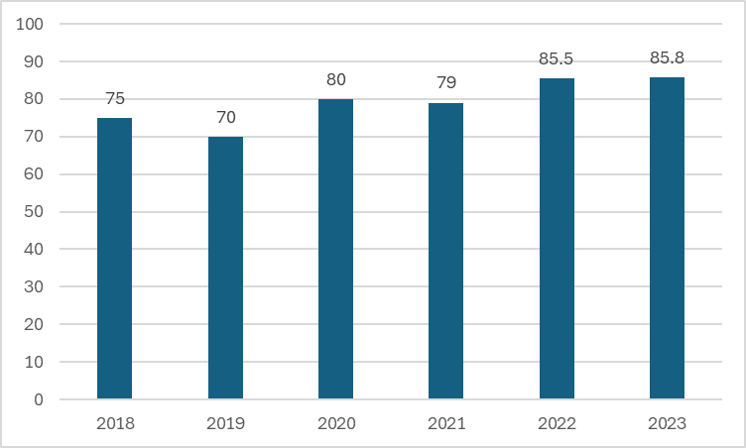

The PMTCT trend above shows that in 2018 the PMTCT coverage was 75% and fell to 70% in 2019. The coverage rose to 80% in 2020 and dropped to 70% in 2021. The coverage rose again to 85.5% in 2022 and just rose by 0.3% in 2023. The rise and fall of the performance coverage may be attributed to shortages of nurse in the PMTCT departments due to attrition.

The second indicator tracking the performance of eMTCT is HIV Exposed infants receiving a virological test for HIV within 2 months of birth. The indicator measures progress to which infants born to HIV-positive women are tested within the first 2 months of life to determine their HIV status and eligibility for ART. Early Infant diagnosis of HIV (EID) is a priority area for the PMTCT program, the performance of the indicator for EID has been marred by several factors which include loss of trained health care workers who can collect good quality EID specimens resulting in high sample rejection rates. In addition, long turnaround times and inability to accurately report EID coverage were noted to be challenges. Furthermore, it was noted that integration with EPI, nutrition and other services was limited.
The performance coverage of PMTCT-3.1 Percentage of HIV-exposed infants receiving a virological test for HIV within 2 months of birth in 2023 was 81.5% (42,269/51,846) against a set target of 85% resulting in an achievement ratio of 95.5%. The 2023 performance coverage of 89% is an 8% decrease from 81% achieved in 2022. The 2023 achievement ratio was 19.6% decrease as compared 115.5%. The performance increased by 3.3% as compared to 73.70% (41,772/59,697) achieved in 2021.

Figure 4 HIV Exposed infants receiving a virological test for HIV within 2 months of birth

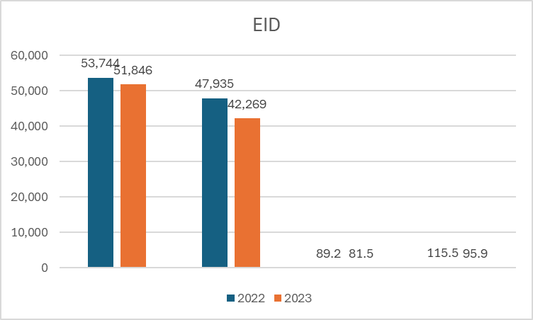

The main reason for the improvement in performance was due to the implementation of IST programme. The Average Turn Around Time (TAT) from specimen collection to receiving at hub decreased to 1.9 days as compared to the set target of 3 days. Specimen rejection rates decreased to 0.66% against under 1% rejection target. This can be attributed to availability of adequate triple packaging material for use during specimen transportation and rider capacitation to improve pre-screening procedures at facilities and carry out correct triple packaging also contributed.

Longitudinal follow up of HEI infants and establishing final outcomes of these infants remain a challenge within the program. To overcome this, the program working in collaboration with the directorate of laboratory services held preparatory meetings to introduce the barcode system with funding support from Global Fund. The barcode will serve as a unique identifier for HIV exposed infants, and will allow differentiation of tests done at birth, 6 weeks and at 9 months in one infant and enable accurate reporting on the EID coverage. A meeting was held in September 2023 to sensitize provincial and district managers on the project. This was followed by training of the healthcare workers from the sites these included FCH nurses, primary counsellors, laboratory personnel and data entry clerks. The five sites participating in the project are Marondera Provincial Hospital, Murewa District Hospital, Seke North Clinic (Chitungwiza), Epworth Polyclinic and Rutsanana Polyclinic in Harare. Following the training, the national team conducted onsite pre-implementation visit for all the learning sites and sites received 15 barcode stickers for each HIV exposed infant. The barcodes are to be kept by the care givers/ mothers in the infants child health card and it was recommended that non- participating sites be sensitised so that there are aware and know what to do when they receive clients who are participating in the project. Key minimum information messages for mothers/caregivers and health care workers including frequently asked questions were developed and printed for the sites. The learning sites will implement the intervention for six months and thereafter lessons learnt will inform national roll-out.

5.2.2 HIV Prevention, Treatment, Care and Support Services
An estimated 1.3 million people were living with HIV (PLHIV) in Zimbabwe in 2022, 1.23 million were Adults and Children under 15 years of age account for 5.7% (74,500) of all people living with HIV. A total of 12 thousand pregnant women (15-24 years) were living with HIV In 2022 and approximately 51,800 HIV positive pregnant women required PMTCT services. The country is implementing the test and treat strategy since 2017 and all HIV positives are eligible for treatment. According to the 2023 HIV Estimates report 17.3 thousand new infections in 2022. There were approximately 13,000 new HIV infections that occurred among adults and 4,200 among children in 2022. Matabeleland South (2.7) had the highest incidence rate per 1000 uninfected population while Mashonaland Central had the least (0.7). HIV incidence rates among adults aged 15 - 49 declined by over 84% from 1.08% in 2010 to 0.17% in 2022, due to the scale up of various HIV prevention and treatment programmes.
It was in this context that UNDP/GF partnership has continued to support the national ART Program to provide services to eligible children and adults with advanced HIV initiated on ART. Provision of lifesaving ARVs to adults and children with advanced HIV has been at the core of the national HIV care and treatment program. Despite the severity of the HIV/AIDS epidemic, its transmission and prevalence in Zimbabwe has been on the decline, this has been demonstrated through the steady decline in the number of AIDS related deaths per 100,000 population from 319/100,000 in 2016; 109.2/100,000 in 2017; 130.9 /100,000 in 2018; 141.5/100,000 in 2020; 164/100,000 in 2021 and dropped to 120.7 in 2022.
The national HIV estimates 2022, had reported a 51% reduction in HIV incidence rates among adults aged 15-49 years. The observed decline in HIV incidence was due to the impact of prevention programs, high ART coverage and viral load suppression amongst the HIV population which stood at 95.03% in 2023. UNDP contributed to the achievement of the results alongside Government of Zimbabwe, and other Health Development Partners in Zimbabwe, including UN sister agencies. Under this outcome UNDP GF’s support over the years contributed to the achievement of prevention of further transmission of HIV, providing care and treatment for those infected and affected with the disease, as well as capacity building for national health systems milestones. UNDP GF contribution over the years has prolonged and saved the lives of Zimbabweans and importantly strengthened the capacity of the national institutions. The MoHCC has been supported to strengthen linkage strategies to ensure that all people that test positive are linked to care.
Adults (15 and above) on ART among all adults living with HIV at the end of the reporting period.
The performance coverage of adults (15 and above) on ART among all adults living with HIV at the end of the 2023 reporting period was 96.3% (1,198,517 /1,235,851) against the set target of 94% which resulted in an achievement ratio of 104%, from 1,745 ART initiating sites. About 96.42% (1,189,793/1,233,934) of patients on ART were adults. More female adults (63.09% or 750,674) than male adults (36.91% or 439,119) were reported to be on treatment during the reporting period. About 20% of patients initiated on ART had Advanced HIV Disease. MOHCC have started assessing gaps in Advanced HIV Disease management noted results from the assessment of Mpilo Centre of excellence. To address the gaps Ministry is working with community cadres such Community Adolescent Treatment Supporter (CATS) to distribute HIV Self Testing kits to peers. Further, the Ministry conducts Index Contact tracing and testing to identify and initiate positive patients on ART. This is also coupled with several treatment interventions such as defaulter tracking to retain these patients in care.
Figure 5 Adults who are currently on ART at the end of December 2023.
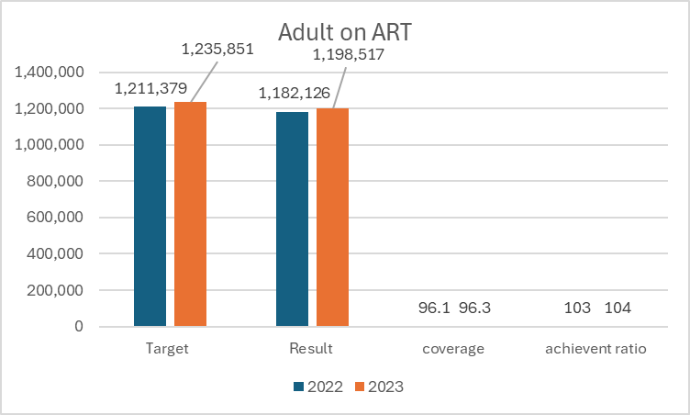
A significant number of Receiver Operating Characteristic (ROC) have no documented CD4 count on re-engagement into care and other clients noted as re-engagement into care would have been receiving ART elsewhere due to challenges coming to the facility, therefore they would not have defaulted ART so as they come back to care CD4 count is not done if the Viral load on returning to the facility is undetectable. Clients who report that they have been taking ART either through buying ART or getting from another facility as a visitor when they come back to care are offered Point of Care VL testing. The main challenges that remain in the implementing process are, that M and E systems are not capturing all indicators for Advanced HIV Disease, scaling up of trainings is slow due to lack of resources, Gaps in medicines and commodities and need to reduce AHD packaging commodities.

Under 15 on ART among all children living with HIV at the end of the reporting period
The indicator measures children who are currently on ART at the end of December 2023
Children currently on ART among all children living with HIV at the end of the 2023 reporting period was 59.2% (44.141/74,587) against set target of 78.2% which resulted in an achievement ratio of 75.7%. The 2023 coverage was a decrease by 12.2% from 71.4% achieved in 2022. The achievement ratio was a decrease by 19.3% as compared to 95% achieved in 2022.
Figure 6 Coverage performance of children (under 15) 2023
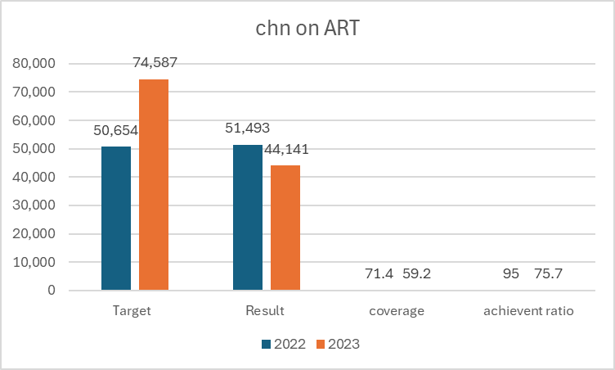

The decrease maybe attributed to a diagnostic, and ART initiation gap for children living with HIV. Further, children could be transitioning to the older age group resulting in lower paediatric ART coverage. Considering the notable gap in performance the MOHCC will address the issue through targeted measures including looking at disaggregated sub-national data and follow-up with districts with data quality issues.
There has been a steady increase in the number of people living with HIV receiving ARVs from 975,667 in 2016 to 1,119,909 in 2017; 1,150,079 in 2018; 1,146,532 in 2019; 1,184,901 in 2020 to a peak of 1,136,246 by December 2021, to as at 1,233,619 December 2022 and 1,233,934 at December 2023. These achievements have been possible due to the role of UNDP as the Principal Recipient of the GF HIV grant for the past 15 years and working closely with the Ministry of Health and Child Care (MoHCC) and the National AIDS Council (NAC) in the timely procurement of ARVs and other pharmaceutical and laboratory commodities, institutional support to the pharmaceutical and laboratory systems, which has saved and prolonged the lives of PLWHIV. UNDP has also collaborated effectively with USG (PEPFAR and USAID) and other Health Development Partners in Zimbabwe to strengthen the health system, including provision of solar systems, to deliver quality health services to the population.
Figure 7 Trends in ART Uptake 2023
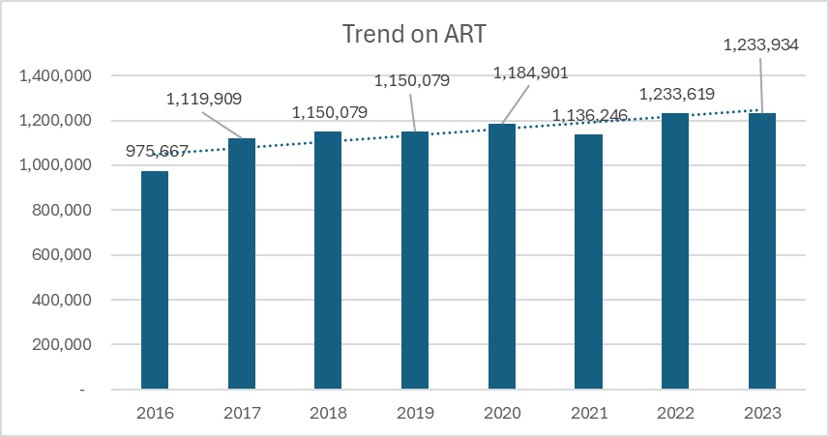
The trend on people on ART has been on an upward trajectory until 2021 when the reported figure fell by 4.1% (48,655). The trend picked up in 2022 and 2023. These achievements have been possible due to the role of UNDP as the PR of the GF HIV grant for the past 15 years and working closely with the MoHCC and NAC in the timely procurement of ARVs and other pharmaceutical and laboratory commodities, institutional support to the pharmaceutical and laboratory systems, which has saved and prolonged the lives of PLWHIV. UNDP has also collaborated effectively with USG (PEPFAR and USAID) and other Health Development Partners in Zimbabwe to strengthen the health system, including provision of solar systems, to deliver quality health services to the population. The 2023 HIV Estimates found that 95 percent of adults living with HIV were aware of their status and of those aware of their status, 99 percent were on antiretroviral treatment. Among those on treatment, 95 percent achieved viral load suppression. The HIV estimates indicate that 72.5% of children know their HIV status which is far below the 95 NSP target. Therefore, the HIV programme will review its progress and design a plan to address this challenge.
HIV-positive results among the total HIV tests performed during the reporting period.
This indicator measures trends in the number of HIV tests conducted (volume) and the proportion which are positive across service delivery approaches and populations. During the period January to December 2023 a total of 1,571,619 men and women of all age groups were tested and received results at the 1,796 facilities offering HTS as compared to 1,392,975 in 2022. Out of the 1,571,619 men and woman who were tested in 2023, 4.9% (77,695/ 1,571,619) tested HIV positive as compared to 5.5% (77,190) who tested positive in 2022. The achievement ratio for the reported indicator for the period 2023 was 98% as compared to 110% in 2022.
Figure 8 Trends in HTS and Positivity, 2023

The decrease in achievement ratio in 2023 may be attributed to stock out raptures of HIV testing kits experienced. There were shortages of HIVST kits and inadequate capacity on use by service providers in some of the facilities.
HTS 5-Percentage of people newly diagnosed with HIV initiated on ART.
This indicator measures trends in the number of HIV positive tested clients and the proportion initiated on ART across service delivery approaches and populations. Out of 77,695 men and woman who were tested 91.4% (70,993/77,695) were initiated on ART during 2023 as compared to the period July to December 2023 a total of 95% (73,188) who were initiated on ART in 2022. The performance coverage was 91.4% in 2023, which was a 3.6% decrease through comparable to 95% in 2022. The achievement ratio decreased by 4.8% as compared to 101% in 2022.

5.2.3 Adolescent Men, Girls and Young Women Programme
The Adolescent Girls and Young Woman and Adolescent Boys and Young Men programmes were being implemented by NAC, Plan International and ZACH. NAC was implementing the sister 2 Sister (S2S) and Male Engagement while Plan International was implementing modified DREAMS and ZACH was implementing SASA/OSC programs. The S2S program targeted out of school adolescent girls and young women between the ages of 10-24. The program provided comprehensive sexuality education through sessions with vulnerable girls and increasing Adolescent Sexual Reproductive health services access and referrals for need based services. The programme was a two-pronged approach which did not only target AGYW but also was focused on male engagement. Plan International was implementing the DREAMS modified in four districts focusing on the provision of Comprehensive Sexuality Education to both Adolescent Girls and Young Women (AGYW) and Adolescent Boys and Young Men (ABYM). The provision of sexuality education and guidance and counselling was a pro-active way of HIV prevention. This strategy was layered with a series of activities that included educational subsidies, study groups, and training of teachers on CSE. These services were meant to keep AGYW in school to attend CSE. ZACH was implementing the SASA! OSC program in six districts to bring positive changes in the community in addressing Gender Based Violence (GBV) and HIV.

S2S and male engagement program performance
Figure 9 S2S program performance
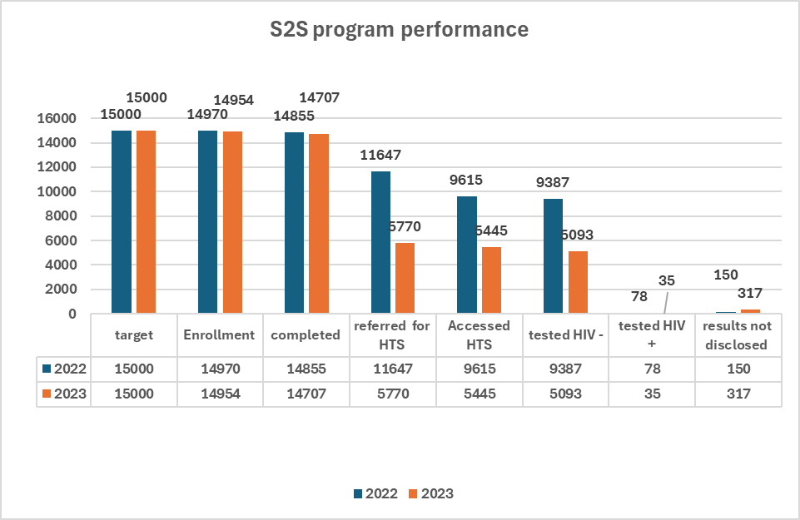
Figure 11 above shows that a total of 99.8% (14,954) AGYW were enrolled in the S2S programme as compared to 99.9% (14,970) enrolled in 2022 against set targets of 15,000 of the targeted 15000 S2S club members were still enrolled at the end of year. Of these, 98.3% (14,707) completed their sessions in 2023 as compared to 99.2% (14,855) who completed their sessions in 2021. The 2023 and 2022 performances are comparable. Out of the 14,707 completed about targeted 40 sessions in the S2S manual. In 2023 about 5,770 club members were referred for HTS as compared to 11,647 referred in 2022. There was a decrease in referrals of 50.6% (5,877). A total of 5,093 tested HIV negative as compared to 9,387 who tested negative in 2022. 35 tested HIV positive in 2023, compared to 78 who tested positive in 2022. and they were linked to care. About 75 301 men were reached by the male engagement program. Of these 565 were referred for HTS.

DREAMS Modified programmes

DREAMS Modified programmes activities covered Education Subsidies, Sustainable and Affordable Boarding Schools (SABS), Comprehensive Sexuality Education (CSE), supply of uniforms and school fees payment.

Education Subsidies
The target for educational subsidies was to support 12,000 in school Adolescent Girls and young woman attending school. The retention of girls is key in HIV prevention as evidence indicates that each additional year of secondary schooling leads to an absolute reduction in the cumulative risk of HIV infection by 11.6% among AGYW.

Figure 10 Education Subsidies

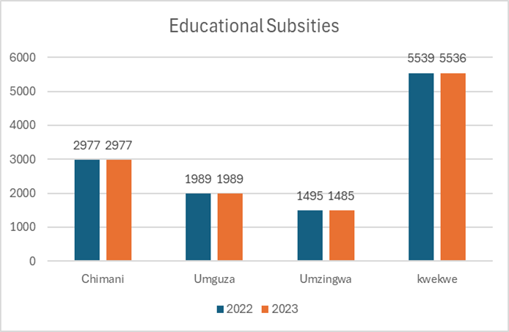

In 2023 there was retention of 99.9% (11,997) learners as compared to 100% (12,000) in 2022 in 111 schools; The figures for 2023 can be disaggregated by district as follows Chimanimani (2977), Umguza (1989), Umzingwane (1485) and Kwekwe (5536).

Sustainable and Affordable Boarding Schools (SABS)
The competition and occupation of the SABS was a relief to AGYWs. UNDP It supported the seven operational SABS in making decisions that improved the availability of safe spaces for 171 girls who otherwise would have walked long distances to school or renting in shopping centers, where they would be exposed to risky sexual behaviors that exposed them to HIV. The fencing and borehole drilling procurement process was completed by the SR. The National AIDS Council supported the SABS facilities through drilling of boreholes in all the SABS. Outstanding is the delivery of the perimeter fence for the Umguza and Umzingwane districts.

Comprehensive Sexuality Education (CSE)

Comprehensive Sexuality Education (CSE) is a curriculum-based process of participatory teaching and learning about aspects of sexuality. It aims at equipping children and young people with knowledge, skills, attitudes and values that empower them to realize their sexual and reproductive health well-being and rights; develop healthy interpersonal relationships; reflect on the impact of their choices on self and societal well-being; and secure and protect their rights throughout their lives.

The AGYW program was tracking indicator YP-1a: “Percentage of young people aged 10-24 years attending school reached by comprehensive sexuality education and/or life skills-based HIV education in school.’’ This was an annual performance tracked indicator of AGYW and ABYM who attended and completed at least five out of six CSE sessions. In 2023, the project managed to reach 47,322 people (24,519 AGYW and 22,803 ABYM) against a target l of 44,777 this was a total reach of 106%.

Supply of uniforms and school fees payment.
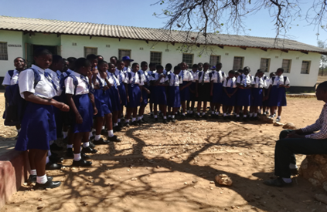
IIn 2023 uniforms were distributed to 12,000 AGYW in the 111 secondary schools that the project supports. Two dresses or skirts, two blouses, a bag, two pairs of socks, a jersey, and a pair of school shoes were given to each project participant. The uniform support has allowed the young women and girls enrolled in school to continue preserving their dignity by allowing them to dress appropriately for school.

5.2.4 Key Population Programmes
The sex work and Men having Sex with Men programmes remains at the heart of the national HIV response in Zimbabwe. UNDP/GF partnership provides a more targeted response for sex workers alongside other vulnerable key populations. The program specifically monitors KP-1c⁽ᴹ⁽ Percentage of sex workers reached with HIV prevention programs - defined package of services, HTS-3c⁽ᴹ⁽ Percentage of sex workers that have received an HIV test, KP-6c Percentage of eligible sex workers who initiated oral antiretroviral PrEP during the reporting period, KP-1a⁽ᴹ⁽ Percentage of men who have sex with men reached with HIV prevention programs - defined package of services, HTS-3a⁽ᴹ⁽ Percentage of men who have sex with men that have received an HIV test during the reporting period and know their results KP-6a Percentage of eligible men who have sex with men who initiated oral antiretroviral PrEP during the reporting period. The performance of the indicators on Sex Work programme is given figure 14 below.
Figure 11 Performance of Sew Work Programme indicators
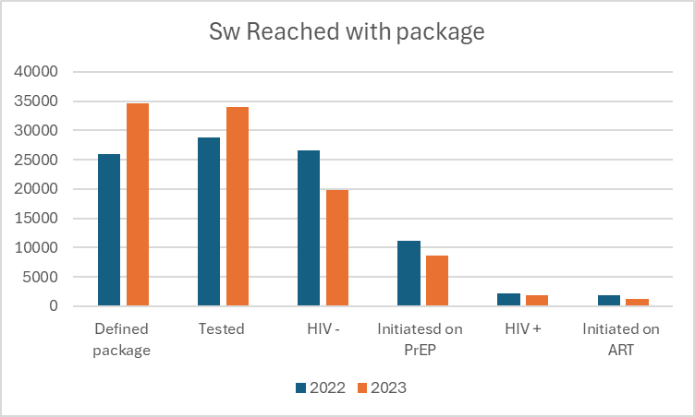
Sex Workers reached with HIV prevention programs - defined package of service.

This indicator aims at ensuring provision of a defined package of services at each encounter between members of the KPs (Sex Workers) and the service providers. In the Zimbabwean context, a sex worker will be counted as "reached" if they are given the following defined minimum package: (1) SRH information i.e peer education, (2) Risk assessment, including HIV risk and STI/TB/GBV screening, and risk reduction counselling, (3) Offered reasonable access to condoms and lubricants, either directly provided by peer educators or made available through dispensing machines in hotspots and/or clinics (4) Offered an HIV test if deemed relevant during the risk assessment, and provided the test if consent is given.
For the reporting period January to December 2023, 77% (34,633/45,000) Sex Workers (SWs) were reached with the minimum package as compared to the set target of 56.8% (25,480/45,000) which resulted in an achievement ratio of 137%. The performance in 2023 was an increase by 19.1% as compared to 57.9 (26,037/45,000) achieved in 2022. The achievement ratio was as 30% increase compared to 107% achieved in 2022. The performance increase may be attributed to attributed to the intensified outreach activities including night and weekend outreach by the 12 static sites which were intensified from both static and highway mobile sites and leveraging of funding from PEPFAR supporting implementation of key population programs facilities. In addition, it may also be attributed to strategic mobilisation by micro planners in their hotspots without. The program has a total of 561 Micro-planners, 317 GF and 244 PEPFAR. CeSHHAR’s microplanners are resident in the hot spot sites continue to mobilize sex workers to come for HIV prevention package and HTS. The programme is being implemented in 12 static sites of which 75% (9) sites have combined funding from PEPFAR and Global Fund, a) whilst 3 (25%) sites - Kadoma, Karoyi and Chinhoyi - are the static sites supported with solely GF resources. 31 outreach sites were visited during the semester under review of which 6 outreach sites are co-funded by GF and PEPFAR and the remaining 25 are funded by Global Fund.

Sex Workers that have received an HIV test during the reporting period and know their results.
During the reporting period 33,969 (130%) sex workers received an HIV test and know their HIV against the set target of 60% (15,606/26010) with an achievement ration of 217%. The performance was an increase of 19% as compared to 111% (28,787/26,010). The achievement ratio was an increase by 32% as compared to 185% achieved in 2022. The reported results have been calculated based on resources invested in the sex work programme. GF and PEPFAR are implementing this activity within the same and/or similar geographical areas, providing services to the same KP/community, and using the same primary source documents for reporting. The programme is being implemented in 12 static sites of which 75% (9) sites received funding from both PEPFAR and Global Fund, whilst 3 (25%) sites – Kadoma, Karoi and Chinhoyi are supported by GF resources only. The same reason cited for good achievement in 2023 for prevention programs - defined package of service applies for the HTS.
Eligible sex workers who initiated oral antiretroviral PrEP during the reporting period

This indicator assessed the availability and uptake of PrEP, among high-risk groups like Sex Workers and who were eligible as per the national guideline.

During the reporting period about 8,714 Sex Worker were initiated on oral antiretroviral PrEP, showing a coverage of 33.5% out of a population of 26,010 Sex Workers, This is an increase by 7.2 (586) from 8,128 Sex workers initiated on PrEP in 2022 the achievement ratio was 67.0% a decrease by 19.1% compared to 86.1% achieved in 2022.
During the last year of the grant a total of 19,870 tested negative as compared to 26, 620 showing an increase by 44% on those tested negative in 2023. Out of those who tested negative 16,500 were screened for PrEP and 14,673 were found to be eligible for PrEP. Out of the Sex Workers who were found eligible for PrEP in 2023 about 8,714 were initiated on PreP as compared to 11,163 showing an initiation decrease in 2023 by 28% (2,449). About 1,930 sex Workers tested positive in 2023 as compared to 2,177 showing a decrease by 12.8 (247) Sex workers who tested positive in 2023.

Men who have sex with men (MSM) reached with HIV prevention programs - defined package of services.

The Men who have sex with Men (MSM) programme is running in 3 Drop-in-Centers (DICs) that are under Gays and Lesbians of Zimbabwe (GALZ) covering the Northeastern region of Zimbabwe and 2 drop-in centers under Sexual Rights Centres covering the Midlands and Southern region of Zimbabwe. The MSM programme is tracked by indicators that measures the performance of HIV prevention programs among Key Populations by monitoring men having sex with men who were reached with comprehensive HIV prevention packages to influence reduction of the risk of HIV transmission. MSM tested and received their results and MSM initiated on PrEP during the reporting period. The performance of the three MSM indicators is shown as in the figure15 below

Figure 15 MSM programme indicator performance
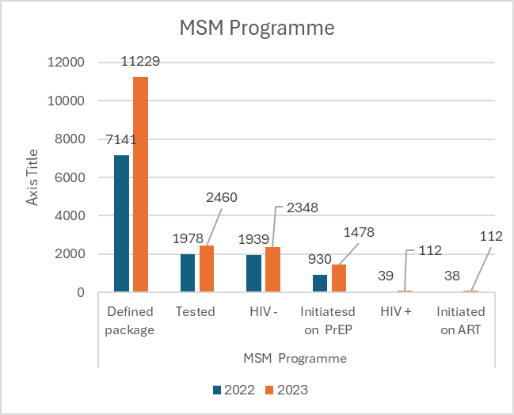

Men (MSMs) were reached with HIV prevention programs - defined package of services

This indicator aims at ensuring provision of a defined package of services at each encounter between members of the KPs and the service providers. In the Zimbabwean context, the minimum comprehensive package is defined as when an MSM is reached by at least two of the following, a) brief sexuality counselling, b) behavioural interventions to support risk reduction, c) mental-health services, d) psychosocial counselling, e) support, and f) treatment Adherence counselling

For the reporting period January to December 2023, 48.1% (11,229/23,326) Men having Sex with Men (MSMs) were reached with HIV prevention programs - defined package of services as compared to the set target of 37.5 % (8,748/23,326 which resulted in an achievement ratio of 126.7%. The performance in 2023 was an increase by17.5 % as compared to 30.6% (7,141/23,326) achieved in 2022.The achievement ratio was a 30% increase compared to 107% achieved in 2022. The performance increase may be attributed to significant increase in year 3 reporting period could be explained by an acceleration plan which was implemented during the reporting period. The implementing partners conducted high volume activities which reached out to MSM in large numbers. These activities were the Proud to serve Campaign, SRHR Dialogues, community health outreaches and weekly clinics conducted in partnership with Wilkins Hospital in Harare, CeSHHAR clinics in Mutare, Masvingo, PSH in Gweru and Bulawayo.

Men who have sex with men that have received an HIV test during the reporting period and know their results.

The indicator measures progress made in providing HIV testing services to MSMs. Targeted testing and counselling in locations and population groups with the highest risk and disease burden as one of the most efficient ways of reaching out to PLHIV and to ensure that they know their status. This indicator measures the effectiveness of HIV interventions targeting populations at higher risk of HIV infection.

During the reporting period 13.4% (2 460/18,404) MSM received an HIV test and knew their HIV against the set target of 34% (6,134/18,40) with an achievement ratio of 39.4%. The performance was an increase of 2.7 % as compared to 10.7% (1,978/18,404) achieved in 2022. The achievement ratio was an increase by 6 % as compared to 33.4% achieved in 2022.

The main reason for the slight increase in year 3 could be explained by the implementation of acceleration plan through outreach activities twice during the reporting period in the 25 outreach sites by both GALZ and SRC after a delay of 44 days that occurred during Q9 when UNFPA delayed disbursement to IPs. The, implementing partners conducted high volume activities which resulted in reaching out to MSM in large numbers. In GC7 the bureaucratic structure which was resulting in delays in financial disbursement has been removed. Funds will be disbursed to NAC by (PR) and from NAC (SR) to KP partners. The Country put a strategy and activities to improve the performance of this indicator in GC7. MSM clients prefer HIV Self-tests and not the rapid blood-based HIV test. As a result, for HIVST was excluded from the HTS reported in line with the country’s reporting guidelines.

Eligible MSM who initiated oral antiretroviral PrEP during the reporting period

This indicator assessed the availability and uptake of PrEP, among high-risk groups and who were eligible based on the national guideline. fDuring the last year of the grant a total of 2,348 as compared to 1,939 who tested negative in 2022 showing an increase by 21% (409) in 2023. Out of those who tested negative 2,175 were screened for PrEP and 1,858 were found to be eligible for PrEP. Out of the MSM who were found eligible for PrEP in 2023 about 1,478 were initiated on PreP as compared to 930 showing an initiation decrease in 2023 by 58.9% (578). About 112 MSM tested positive in 2023 as compared to 38 showing an increase by 189.7% (74) Sex workers who tested positive in 2023. All the 112 MSM who tested positive were initiated on ART.

5.2.5 Performance of RSSH indicators

In year 3 UNDP continued supporting implementation of the 5 RSSH, PSM indicators and these were PSM-3 Percentage of health facilities providing diagnostic services with tracer items available on the day of the visit or day of reporting PSM-4 Percentage of health facilities with tracer medicines for the three diseases available on the day of the visit or day of reporting PSM-7 Percentage of health product batches for the three diseases tested for quality in line with Global Fund Quality Assurance policy, . The performance of the indicators is as given in the below table

Table 7 Performance of RSSH Indicators 2023

Coverage Indicator | Target | Results | Achievement Ratio
PSM-3 Percentage of health facilities providing diagnostic services with tracer items available on the day of the visit or day of reporting | 1,781/1,836 (97%) | 1,777/1,850 (96.1%) | 99%
PSM-4 Percentage of health facilities with tracer medicines for the three diseases available on the day of the visit or day of reporting | 1,677/1,711  (98%) | 1,726/1,727  (99.9%) | 103%
PSM-7 Percentage of health product batches for the three diseases tested for quality in line with Global Fund Quality Assurance policy | 120/120 (100%) | 99/120  (82.5%) | 83%
M&E-2a Completeness of facility reporting: Percentage of expected facility monthly reports (for the reporting period) that are actually received. | 18,036/20,040  (90%) | 20,978/21528 (97.4) | 108.3%
HRH-1 Vacancy rate: Number of full-time posts unfilled for at least 6 months as a percentage of total number of funded posts | 2,240/37,332(6.00%) | 2,137/31,571  (6.8%) | 89%

Tracer commodity for HIV diagnostic services
In the Zimbabwean context, the tracer commodity for HIV diagnostic services for the general population is the HIV screening test kit Determine HIV-1/2.There were 1,850 facilities expected to provide diagnostic services and stock the HIV Screening Test kit in 2023. During the reporting period, 100.0% (1,850/1,850) of the facilities were visited. For Jan to Dec 2023 reporting period, of the facilities visited 96.1% (1,777/1,850) of the health care facilities providing diagnostic services had the tracer item on the shelf on the day of the visit or on the day of reporting against a target of 96% which resulted in an achievement ratio of 99%. The achievement ratio and coverage are comparable with the achievement in 2022 which had 96.7% and 102% respectively.

The 4% non-availability of the tracer commodity may be attributed to the fact that there were stocks below minimum in Q1 of 2023 (1month of supply was in central warehouse) leading to failure in meeting maximum order fill when the stocks were between minimum and maximum throughout the year. About 3.9% (73/1, 850) of the facilities visited did not have determine stock. The facilities that had no stock may be disaggregated by Provinces as follows: Bulawayo 1.4% (1), Harare 8.2% (6), Manicaland 17.8% (13), Mash Central 5.5% (4), Mash East 4.1% (3), Mash West 12.3% (9), Masvingo 17.8% (13), Mat North 9.6% (7), Mat South 5.5% (4), Midlands 17.8% (13). In GC7 the PR will work with MOHCC to further analyse Provincial/district level stockout and target those with low ART linkages.

Health facilities with tracer medicines for the three diseases available on the day of the visit or day of reporting
There were 1,735 facilities expected to stock the tracer medicine. In the Zimbabwean context the tracer medicine for the HIV disease is TLD. Out of these facilities 99.54% (1,727) were visited during Jan to Dec 2023 reporting period, The tracer for HIV disease is TLD, which has 90 count and 30 count packs in circulation in the country. Of these 99.94% (1,726/1,727) health facilities had the tracer medicine in stock on the day of the visit against a target of 98%, reflecting a performance ratio of 101.98% (99.94%/98%), which is an improvement from 99.81% (1,558/1,561) in 2022, with a performance ratio of 101.8% (99.81/98).The reason for meeting the target may be attributed to improved fill rate in the previous cycle as shipments were in sync with the distribution and ministry was able to meet health facilities demand.
Health product batches for the three diseases tested for quality in line with Global Fund Quality Assurance policy
This RSSH Indicator measures the proportion of health product batches for HIV, tested for quality in line with the Global Fund Quality Assurance policy. In line with the GF Indicator Reference Sheet - Version 2020, Quality testing is part of the National QC Plan, or program-specific QC Plan shared and approved by Global Fund. In the Zimbabwean context, Quality Assurance is done at the National lab pre-distribution or post-surveillance.
During Jan to Dec 2023 reporting period, 82.5% (99/120) of health product batches for HIV were tested for quality assurance in line with Global Fund Quality Assurance policy against the target of 100% which resulted in an achievement ratio of 83% which was comparable with 85% (102/120) achieved in 2022. All the tested batches passed the QA tests. MCAZ tested 137 samples of ARVs of which 20 samples were from single, 25 double, and 92 triple ART formulations in 2023.The target was not met due to ARV samples tested from the same batch at different levels (national, provincial and health facility) but reported as one based on the indicator definition. The methodology for sampling and testing is based on risk-based protocols (considering the total number of sampling units, disease prevalence and consumption data). Unknown storage conditions were classified as the highest risk. The result can be disaggregated by formulations and pass/fail as follows: Single formulation 12 (12.1%), Dual formulation 24 (24.3%), and Triple formulation 63 (63.6%).
Completeness of facility reporting
There were currently 1,794 Health Facilities expected to be reporting monthly to district level monthly and in total 21, 528 reports were expected. The performance of this indicator was 97.4% (20,978/21,528) during the January to December 2023 as compared to the set target of 90.0% (18,036/20,040) which resulted in an achievement ratio of 108.3%. The performance of the indicator was an increase by 9% as compared to previous year of 88.4%. The achievement ratio of 108.3% is comparable with the 104% achieved in 2022.
All provinces performed above the 90% national target. This good performance may be attributed to trainings in data management and analysis conducted and the distribution of laptops to the Health Information personnel done during the year. Harare province (94.4%) had the lowest coverage followed by Bulawayo province (94.7%). This may be attributed to large number of private facilities that did not report and municipal health facilities that are not operating optimally due to staff shortages. The highest performing province was Matabeleland South Province (99.2%) followed by Mashonaland Central (99.0%) and Masvingo (98.9%) Provinces.
While the performance continues to improve, there are still several challenges that need to be addressed to improve performance in the GC7 grant and these are: Availability of the internet in some facilities, Electricity challenges and unavailability of backup power, and Low coverage among private sector health facilities.
Vacancy rate: Number of full-time posts unfilled for at least 6 months
During Jan to Dec 2023 reporting period, a total of 2,137 full-time Health Workers' posts were vacant for at least 6 months out of the 31,571 funded Grade C5+ posts which resulted in 6.76% attrition rate as compared to the set target of 6%. This is a reverse indicator and the achievement ratio 89% is higher than the achievement ratio of 64% in 2022 which showed in the decline of unfilled posts in the funded posts. The current vacancy rate of is also 6.77% which is lower than the Semester 4 attrition rate of 11%. The improvement in performance may be attributed to payment of a portion of their salary in USD and the implementation of the GF supported retention scheme. To slow down the attrition, Government in July 2020 made a 100% adjustment on basic salaries and generic allowances (housing, Transport and Representation Allowances. Additionally, Government introduced USD rated health sector specific allowances (on call, Night Duty, Nurse Managers, Special Health and Stand by Call out) as well as Covid allowance. Payment of the GF approved Health Workers Retention Scheme for Grades C5+ from April 2022 to December 2023 could be the reasons for the decreased vacancy rate for 2023. However, the vacancy rate of 6.77% is still high which may be a supply-side failure, where there were no candidates to recruit and fill the posts from the health Labour market.
The overall establishment of the Ministry of Health stood at 52,118 with 44,652 Health workers in post representing a vacancy rate of 14%. The most affected are the nurses 907 (42.4%), Doctors 378 (17.7%), and Laboratory Scientists 186 (8.7%). The Nursing staff category had the highest number of posts that could not be filled with 907 posts vacant for at least 6 months, for example, the RGN had 675, PCN recorded 60 and Nurse in Charge had 68 posts that remained vacant for at least 6 months. Doctors had 378 vacant for at least 6 months in 2023, the highest sub-staff category was the Government Medical Officer with 148 posts, 74 HOD Specialist. The Pharmacy Services staff category recorded 79 posts vacant for at least 6 months with the Senior Pharmacy technicians recording 40 and the Senior Pharmacist having 32 posts vacant for more than 6 months. The Laboratory Services staff category had 186 posts that remained vacant for at least 6 months sub-categories with a higher number of posts that could not be filled for at least 6 months were medical laboratory scientist 156 and state-certified medical laboratory technician with 18 posts were vacant for at least 6 months. Radiography recorded 54 vacant posts for at least 6 months of these 47 posts were for the Radiographer Senior/Principal/Diagnostic/Ultrasound. In the long term to address these challenges, the HSC has conducted a comprehensive Health Labor Market analysis, which informed the development of the new HRH strategy. This process should lead to the development of an HRH investment compact and salary harmonization. With evidence-based policies on HRH, it is hoped that some of the factors leading to out-migration and high attrition of health workers will be addressed.
Figure 12 Number of attritions by category of staff 2023.

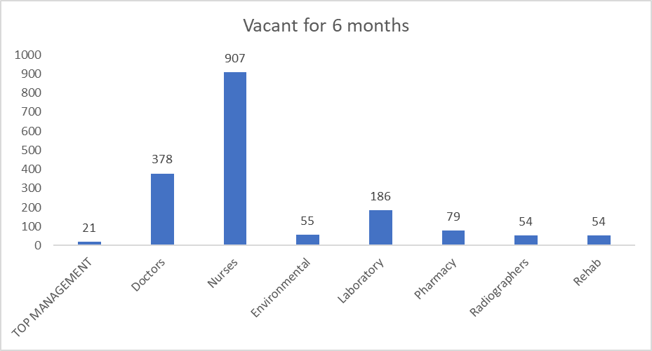
Payment of Health Workers’ Retention Allowances
On average, 26,461 Health Workers from grade C5 and above were paid their monthly allowances from January to December 2023. These consisted of 6,981 health workers from the special category and 19,480 from grade C5 and above.
Village Health Workers (VHWs)

Village Heath Workers (VHWs) plays a central role in the health service delivery as they act as an interface between the primary health facilities and the community. The duties of a VHW include treating minor ailments, providing medical and psychosocial support to chronically ill patients at home, following up on patients, identifying problems in the community and advising the rural health centres accordingly. The VHWs are expected to work for 2-3 days per week. However, due to the increasing burden from HIV and AIDS and TB, the job of the VHWs has now become almost full time.
The grant made provision for the payment of US$42 per VHW per quarter. The MoHCC is responsible for the supervision and payment of allowances to 120 VHWs in each of the 62 districts and hence the total number of VHWs to be paid is 7,560. Over the reporting period, on average 6,195 VHWs were paid their monthly allowances from January-December 2023. The payments were done through 4 banks namely CBZ, Zimbabwe Bank (ZB), POSB and Agri bank, where the VHWs opened Low-Cost Maintenance Nostro Accounts.
Implementation of Integrated Sample Transportation (IST)
Volume of VL and EID Specimens and Results Transported The total number of VL /EID specimens and results transported between January and Dec 2023 was 164,843 and 144, 146 respectively (Figure 12). There is a 1.9% (1,522) decrease in specimens transported between sem 6 (82,161) as compared to sem 5 (82,683). How urn Around Time
2023
Volume of VL and EID Specimens and Results Transported The total number of VL /EID specimens and results transported between January and Dec 2023 was 164,843 and 144, 146 respectively (Figure 12). There is a 1.9% (1,522) decrease in specimens transported between semester 6 (82,161) as compared to semester 5 (82,683). However, there was a 0.1% increase in VL/EID results transported in semester 5 (72,020) as compared to semester 6 (72,126). The lower figures in January are because of inclement weather, where there was incessant rain during this period, with a good number of sites not accessible. The difference between specimens and results can be attributed to laboratory testing backlogs due to equipment downtime or reagent stockouts. The TB samples transported during the period were 19, 503 as compared to 18,609 results. There was an increase by 16% (1,443) of TB samples transported in sem 6 (10, 473) as compared sem 5 (9,030). There was also an increase by 21.3% on results transported in sem6 (10,200) as compared to sem 5 (8,409)
ever there was a 0.1% increase in VL/EID results transported in sem 5 (72,020) as compared to sem 6 (72,126). The lower figures in January are because of inclement weather, where there was incessant rain during this period, with a good number of sites not accessible. The difference between specimens and results can be attributed to laboratory testing backlogs due to equipment downtime or reagent stockouts. The TB samples transported during the period were 19, 503 as compared to 18,609 results. There was an increase by 16% (1,443) of TB samples transported in sem 6 (10, 473) as compared sem 5 (9,030). There was also an increase by 21.3% on results transported in sem6 (10,200) as compared to sem 5 (8,409)
Figure 13 Implementation of Integrated Sample Transportation (IST) 2023

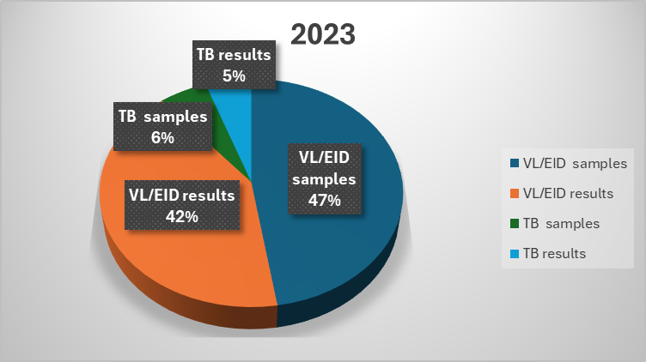

HIV, Health and Development

Through the #WeBelongAfrica initiative and the Unified Budget Results Accountability Framework (UBRAF), UNDP has channelled complementary efforts in responding to the legal, policy, human rights, and gender-related barriers to HIV services for Key and vulnerable populations. UNDP continues to support the government entities in Zimbabwe to become increasingly responsive to SRHR for Key Populations which in turn will contribute to KP inclusive laws, more responsive public sector services, and social norms that affirm key and vulnerable Populations' needs and rights. In the year 2023, UNDP supported the underserved key population groups to engage with the Grant Global Fund to strengthen human rights response in the Grant cycle seven funding request process.

ICASA 2023 provided an opportunity for UNDP to highlight successful approaches for YKP inclusion through increased capacity for YKPs and amplifying their voice through the Young Key populations networking zone and a visual media campaign.

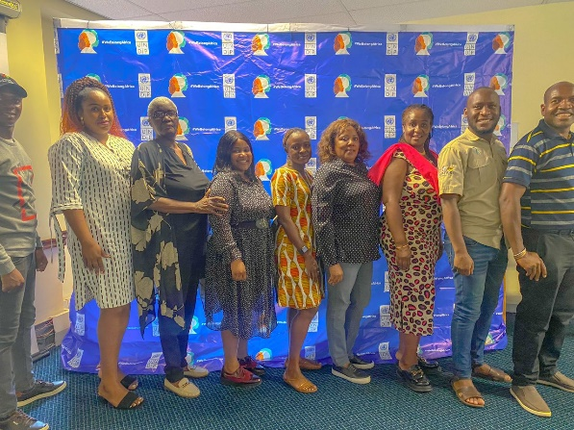
The WeBelongAfrica National Steering Committee has been central in increasing attention to Zimbabwe's commitment to addressing the rights and priorities of Key population groups. In the year 2024, the committee will also play an important role in the scheduled review and update of the 2018 Zimbabwe HIV legal environment assessment that will provide a robust analysis of legal and policy barriers and impact HIV access, particularly for key population groups such as MSM, transgender persons, sex workers in their diversity and persons who use and inject drugs.

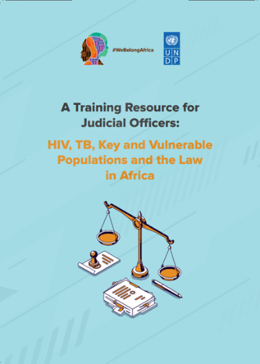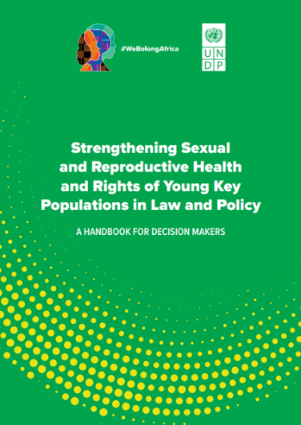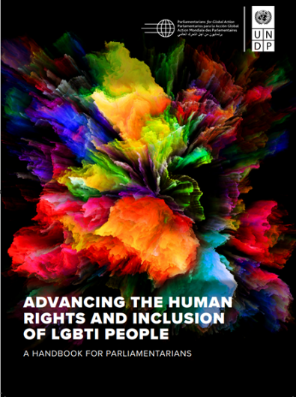

The Key Populations program continues to operate in a context of stigma discrimination and public disapproval of Key Populations SRHR rights by influential political actors and the #WeBelong Africa program has produced and disseminated important Key Populations inclusion resources such as the Parliamentarians handbook, HIV training recourse for judicial officers, YKP inclusion handbook for decision-makers to support senior government officials and political actors to strengthen key populations inclusion in HIV response.

Covid 19 Response Portfolio optimization Wave 2
In 2023, the program was implemented in an environment where COVID-19 restrictions were removed. All remaining COVID-19 related movement restrictions were lifted in July 2022. In August 2022, the mandates for wearing masks were also removed, following a decline in daily COVID-19 cases, this enabled SRs to implement their planned activities smoothly.

Infrastructure activities/Solar Systems

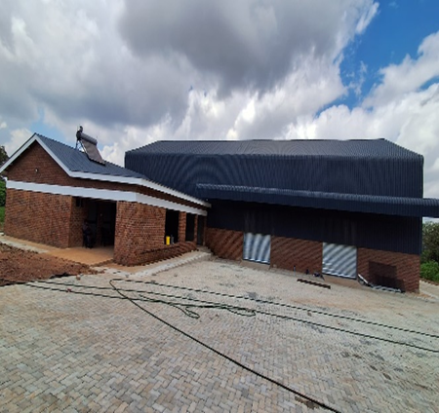
The construction works of Mutare Medical Warehouse is at 100% and MoHCC requested that power connection occur before handover. The construction of 119/178 Pharmacy stores have been completed; the 33 Pharmacy stores is at 87%; and 26 Pharmacy stores is 90%. Renovation of labs located at four border towns progress is at 70% and expected to be completed by 30 April 2024. The construction of incinerator housing units at Mpilo and Sally Mugabe hospitals are ongoing and at 94% and 89% respectively. The Upgrading and Renovation of the NTB Reference Lab civil works is at 12%, HVAC system under technical evaluation and medical equipment will be delivered at the end of April 2024. The installation of containerised laboratory and Renovations of National Bio Reference Laboratory at Sally Mugabe is at 96%. For X rooms preparation, the progress is estimated at 50 % for 30 sites. For the Isolation centres project and oxygen reticulation, the MoLGPW is yet to submit the final design package that is the drawings and BOQs.
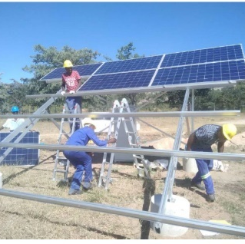
The installation of solar water borehole systems at 447 health facilities has been completed and all boreholes have been certified. The solar for Health (S4H) project in Zimbabwe started in 2016 as a response to the frequent electricity blackouts that were occurring in the country. The blackouts were affecting the provision of quality health services at most of the public institutions as they lasted the better part of the day. Thus, UNDP in partnership with the Ministry of Health and Child (MOHCC) secured funding from the Global Fund to install solar systems at public health institutions to consolidate and strengthen the fight against the 3 diseases namely HIV &AIDS, and Tuberculosis, and Malaria.The initiative has led to the second phase of 640 solar systems at 639 sites which are 100% complete. The third phase of installations includes 19 solar sites (3 under the COVID-19 grant and 16 under the main HIV grant) which are at 90% completion. Preventive and Corrective maintenance for 16 sites in Mashonaland Provinces are 100% complete. For the battery replacement project, lot 1 to lot 4 with a total of 403 sites, the overall progress is at 30%, waiting for the delivery of batteries from China.The optimization of 22 by 40kWp solar systems was completed. The installation of the solar system at MCAZ is 100% complete and was certified. The installed solar systems have become the primary source of energy with the grid becoming the backup source of energy. Below is a spatial distribution of installed solar systems and boreholes.
To date, a total of 1053 solar systems ranging from 5kwp to 40kwp have been installed in different public health facilities distributed across the country.
Table 14 Installed S4H and Borehole systems per province December 2023
Item | Province | Type of Installations | Total installed
1 | Masvingo spread across 7 districts | Solar Systems | 108
1 | Masvingo spread across 7 districts | Solar Boreholes | 86
2 | Harare spread across 4 districts | Solar Systems | 52
2 | Harare spread across 4 districts | Solar Boreholes | 23
3 | Bulawayo spread across 4 districts | Solar Systems | 28
3 | Bulawayo spread across 4 districts | Solar Boreholes | 13
4 | Matebeleland North spread across 7 districts | Solar Systems | 102
4 | Matebeleland North spread across 7 districts | Solar Boreholes | 61
5 | Matebeleland South spread across 7 districts | Solar Systems | 108
5 | Matebeleland South spread across 7 districts | Solar Boreholes | 64
6 | Midlands spread across 8 districts | Solar Systems | 139
6 | Midlands spread across 8 districts | Solar Boreholes | 54
7 | Mashonaland Central spread across 8 districts | Solar Systems | 130
7 | Mashonaland Central spread across 8 districts | Solar Boreholes | 23
8 | Mashonaland East spread across 9 districts | Solar Systems | 121
8 | Mashonaland East spread across 9 districts | Solar Boreholes | 46
9 | Mashonaland West spread across | Solar Systems | 120
9 | Mashonaland West spread across | Solar Boreholes | 53
10 | Manicaland spread across 7 districts | Solar Systems | 176
10 | Manicaland spread across 7 districts | Solar Boreholes | 71

The solar systems installed by UNDP cover 65% (1,045/1,600) of the public health facilities in Zimbabwe.
S4H Sustainability Plan
To ensure that the installed solar systems are kept running well, a sustainability plan is in the process of being developed. The Sustainability Plan is being developed across 5 countries namely Malawi, Zambia, Namibia, Liberia, and Zimbabwe. In Zimbabwe, the focus of the plan is on Operations and Maintenance (O&M). In addition, Zimbabwe is also pursuing to develop a sustainability Plan focusing on Zimbabwe alone.

Procurement and Supply Chain Management
The PR continued to work with the Ministry to ensure that essential medicines including antiretrovirals, and laboratory reagents & consumables were available on time by the supply plan. Advance shipments that were approved in 2022 following the August Quantification continued to be received as per the pipeline requirements. In February 2023, the Ministry of Health and Child Care Quantified all health commodities with UNDP support. Following the Quantification a supply Plan was developed. The Supply Plan and the Quantifications were reviewed and approved. There were no funding gaps identified for both Pharmaceuticals and Marker Laboratory commodities. The Annual Quantification resulted in the Global Fund approving procurements of the health products for the rest of the Grant including provisions for 8-month stock after the end of the grant for Pharmaceuticals (First Line Antiretrovirals). All Antiretrovirals which were requested by the Ministry were ordered. A total purchase order value of USD 25,010,159.82 was established for these . Similarly, Laboratory commodities were also ordered as per the Ministry request and a Total value of USD 11,383,929.85 Purchase Orders were established .The confirmation of the orders was done on time and commodities were received as per the National Pipeline resulting 100% availability of especially tracer commodities.

Non health commodities were also procured as per the request from programme and below is summary of the procurement

Table: 2023 Non-health Procurement Cases at Glance
Item Description | Amount USD | Percentage (%)
Total Value and volume of non-health product planned. | 24,661,414.38
Total value and volume of non-health products procured. | 20,137,449.40 | 82

WFP is the SR that is responsible for ensuring all the health and non-health products arrived in the country safely, in the right quantities and quality. Under the reporting period WFP handled the clearing for import all health and non-health products and offloaded them at UNDP Partners’ Warehouses. It ensured proper storage and handling of non-health products before they were distributed to the intended beneficiaries. The non-health products were distributed to different beneficiaries at the request of UNDP. WFP carried out verification of all delivery documents to ensure that all the health and non-health products were accounted for.

There were several challenges which were faced in the procurement of non health commodities, and these challenges are summarised in Table below
Challenges /Issue | Mitigation Measure
Inadequate Specifications submitted by program or Implementers | Train Programme and implementers on Specifications /TORs and SOW
Late submission of procurement request -with impossible delivery dates | Engage programme to submit procurement cases well in advance, remind them of the UND Statutory days for Procurement for them to appreciate the procurement process
Restriction of Chairmanship of Evaluation committee to FTAs most of which are not available for the timeous review of Tenders | Review the TORs of FTAs to include in the MDP the evaluation and consider NPSA for Chairmanship for the evaluation committee
Non-Availability of Evaluation team members to complete Evaluation on time | Engage Management to inform members that the Evaluation of tenders is critical arm of UNDP which must be prioritized
Late review of cases by CAP secretary | Review the role of CAP secretary especially at the last quarter of the year where several cases will be concluded
Slow /Inefficient Suppliers onboarding on Quantum | Conduct a Supplier conference

The national supply pipeline was continuously monitored using the PR dashboard. The dashboard showed that throughout the country for all antiretroviral products, availability through the year was 100% with some products registering overstock while some were understocked. For instance, in December 2023, all tracer products were available in the country. Review of the stock levels of the products showed that 54% of the ARVs were available within the desired stock level, 23% were available above the desired stock level and 23% were available below the desired stock level. Availability of products above and below the desired stock levels were influenced by the transition of regimen and PSM team worked closely with programme team to ensure stock outs were avoided and
The products will be issued to facilities, if necessary, on named patient basis. The stock status matrix below for ARVs shows the UNDP/GF Contributions to the supply situation of the country.

As earlier noted, UNDP PSM team worked closely with the MOHCC to ensure that stock outs were avoided, and expiries were minimized.
The movement of commodities from central to district level takes place every quarter through ZAPS and ZILACODS distribution systems. By 31 December 2022, ordering had been completed in all provinces with four distributions of health commodities through Zimbabwe Assisted Pull System (ZAPS) for primary care facilities and the ZILACODS for Laboratory commodities.
To facilitate the destruction of waste products, two NatPharm incinerators were refurbished, and commodities have been disposed of in batches. The two giant incinerators procured in 2021 were not received and installed by Dec 2022 because the process of engagement of the civil works contractor was not completed. It is expected that liquid waste and cyanide related commodities will be disposed of using this facility by the end of 2023.
During the year, four oversight visits were conducted to four provinces. The supply chain management of health products continued to improve during the year although some challenges were noted and either resolved on the spot or through an action plan formulated with the facility personnel.

These Challenges includes:
• Inadequate storage space and conditions in most of the facilities
• Unserviced Haematology and chemistry machines
• Non-functional Air conditioning units in some facilities affecting the temperature of storage facilities.
• Inadequate temperature monitoring due to inadequate temperature monitoring devices and lack of air conditioning units.
• Vacant posts for Laboratory Scientists, Pharmacy technicians and some Pharmacists at some central hospitals which are not benefiting from the retention.
• Vacant posts for Laboratory Scientists and technician, at district and provincial hospital

To overcome the challenges posed by inadequate storage space, 128 pharmacy stores and one central warehouse in Mutare NatPharm are being constructed and they will be equipped by the time they will be complete in 2023. The Servicing and maintenance of haematology and chemistry started in Q3 of 2022 and it is expected that by June 2023 all units should have been serviced and maintained.

The e-LMIS project
The e-LMIS project is being implemented through a multistakeholder approach and aims to achieving the objectives of improving end to end visibility of health commodities in the supply chain while effectively reducing pilferage and increasing accountability. More than 800 laptops were purchased to support the rollout of eLMIS. The total number of facilities that have the e-LMIS roll out rose to 400 during 2022.As part of the scale up process, the system was rolled out completely to ten districts in the country with Manicaland accounting for the most with four full districts in total. The rolling out of the e-LMIS to these ten districts provided an opportunity to draw key lessons which would be useful in nationwide scale up. The systematic approach which enabled the rolling out of the system in these districts, is envisaged to expedite the scale up process given the availability of training and hardware resources.
Key challenges to the roll out and functioning of the eLMIS include:
• Connectivity and data access throughout the country. This is being mitigated using an offline version.
• Synching of the data of the offline version is also a problem.
• Low usage of the system as there is always a natural tendency of resistance to change.
• power outages, erratic or non-existent power coverage was noted.
• Software bugs
• High staff turnover at facility level
• User input-based anomalies

The e-LMIS/Navision integration has been successfully completed and tested in the production environment. During 2022, Emergency Orders were successfully tested and placed from the e-LMIS into Navision. Regular orders are planned to be processed in 2023, and this will effectively alter the way ordering systems function. The transitioning to regular e-LMIS ordering will usher in Z.A.P.S 2.0 which is the updated acronym for the Zimbabwe Automated Pull System from the current Zimbabwe Assisted Pull System.

In terms of the integration of e-LMIS/EHR, the process is currently going on and a working prototype is expected by end of Quarter 2 2023. It is expected that in 2023, 110 laboratories and 1400 health facilities will be covered with LIMS bringing the coverage to 100%. The Quality assurance Programme (QAP) continued to be implemented as per the approved plan. The Medicines Control Authority of Zimbabwe (MCAZ) Microbiology laboratory was renovated under NFM2 (2018-2020). The new laboratory was handed over to MCAZ and has resumed operations. From January to December 2022, the laboratory tested and released 17 samples for MoHCC, and all the 17 samples passed analysis.

Monitoring and Evaluation

Review of SR quarterly, semester and annual reports: M&E activities carried out included review all quarterly SR reports and provided feedback, compilation of PUDR with supporting documents and fully participated in the verification of the results with the LFA. The PR also compiled the PR dashboard and Pulse Check on quarterly basis and share with the CCM and GF respectively on time. Fully supported national survey/assessment/reviews including ZDHS, HHFA and ZINASP IV mid-term review. Twenty (20) SR reports out of the expected Twenty (20) planned for the year were reviewed in Sem 4, for (Jul-Dec 2022), Sem 5 (Jan-Jun 2023) Q11 (Jul-Sept 2023) (NAC (8), MoHCC (4), BRTI (4) and NatPharm (4).Five (5) annual reports out of five (5) were reviewed Two (2) for NAC; One (1) for MOHCC; One (1) NatPharm; one (1) for BRTI for the following period: (Jan 2022 to Dec 2022).The 2022 annual report was finalised and shared with PMU management and approved. UNDP Country Office and M&E team also cleared the annual report and was published. In addition, assessment of data sources was done on a quarterly/semesterly for MoHCC, NAC, BRTI and NatPharm during quarterly/ semesterly basis for the period Jul-Dec 2022, Jan – Mar 2023, Jan- Jun 2023, July- Sept 2023.

Technical Support: Three (3) technical support out of the planned Two (2) were provided during PU/PUDR preparation and NAC review meetings for the period Jan -Dec 2023. This was facilitated by discussions done during PU/PUDR discussions that were held during the year. Reminder letters for SR to reminder them of compliance to report submission as a per grant agreement requirement was done and sent to 8 SR for the period Jul-Dec 2022, Jan – Mar 2023, Jan- Jun 2023, July- Sept 2023. In addition, eight (8) technical assistance was provided to SRs during in quarterly/ semesterly reviews of the submitted reports and during report writing, HIV Estimates report writing, GC7 concept note writing, AGYW and KP Biannual review meeting, Patient level data analysis and report writing, tools review workshop.

On Site Data Verification: Three (3) The first OSDV were held during the year. The first covered 6 facilities in Mashonaland Central and Harare Provinces. Key findings showed that the accuracy rate for MoHCC indicators: HTS-1 Number of people counselled and tested and received their results was 114% which shows 14% under reporting, for HTS-4 Percentage of HIV Positive results among the total HIV tests performed during the reporting period was 100% and for HTS-5 Percentage of people newly diagnosed with HIV initiated on ART was 105.3% which shows 5% under reporting. TB/HIV-7 Percentage of PLHIV on ART who initiated TB preventive therapy among those eligible during the reporting period was 38% which shows 61.8% over reporting. SWs reached with HIV prevention package, tested for HIV and PrEP initiations data accuracy was 104.7% which shows 4% under reporting. Assert and PSM verification were also covered during the OSDV exercise.

The second OSDV was done in 5 facilities in Midlands and Masvingo Provinces. Key findings showed that MoHCC data accuracy rate for adults and Children on ART was 94.6% which showed 5.4% under reporting, PMTCT-2.1 HIV-positive women on ART was 87.4% which showed 12.6% under reporting, and TB/HIV-7 PLHIV on ART who initiated TPT was 102% which showed 2% over reporting. SWs reached with HIV prevention package, tested for HIV and PrEP initiations data accuracy was 100 %. GALZ and SRC MSM reached with HIV prevention package, tested for HIV and PrEP initiations data accuracy was 100.3% which shows 0.3% over reporting. Additionally, the OSDV covered financial verification of the decentralised finds on training and salaries for Data entry clerks and Primary Care Counsellors, verification of assets procured under the Global fund grant, and RSSH infrastructure (borehole and pharmacy store).

A third OSDV was done in Mat South, Bulawayo, Chitungwiza and Harare covering Retention Scheme and Village Health Workers (VHWs). The objective was to check physically the presence of Health workers from C5 and above who are being paid retention allowances and the Village Health Workers who are being paid allowances. During the exercise, 216 Village Health Workers (VHWs) and 612 health workers were physically verified. It was observed that at a few facilities, there were delays in updating the database resulting in payment of undeserving cadres.

Spot Checks During the reporting period 4 training spot checks were done by the PMU to check Compliance to training and meeting guideline was done for the following SRs- One (1) for MoHCC (Chinhoyi) and Two (2) for NAC (Masvingo and Mutare) and CeSHHAR

Differentiated Service Delivery (DSD) for ART: Three (3) DSD review meetings, the DSD dashboard staging, as well as participation in the various communities of practice that were held and has committed to including the national CQUIN Annual meeting. The DSD reviews focused on capacity building for healthcare workers from eighteen (18) districts in 6 Provinces on the new DSD guidance in the revised operational and service delivery manual (OSDM). The country participated in the CQUIN annual meeting together with the other 21 member countries and made a country presentation that showcased our work and progress made during the previous twelve (12) months, the successes and the challenges experienced therein. National and Provincial Validation Meetings: The PMTCT program held the 4th quarter validation meeting chaired by the Minister of Health and Childcare. The deliberations centred on regional meeting feedback, local research, and updates. Zimbabwe Network for Positive Men shared data on their work and coverage at the community village at ICASA. During the third quarter of 2023 the Midlands PVC meeting was conducted.
Laboratory Viral Load Implementation: The number of viral load tests done on conventional platforms in the period October to December 2023 is 257 492 which is a 4.2% decrease from the 268 808 tests done in Q2 2023. This decrease can be attributed to lower numbers in Q4 due to extended equipment downtime during the Hologic service provider transition. A stock out of Roche reagents and consumables was also experienced during the same quarter. Out of 257 492 tests done in conventional labs, 247 018 (95.9%) were virally suppressed. By province, suppression levels ranged from 95% in Matabeleland South and Manicaland to 97.3% in Masvingo. During the October to December 2023 period, 7 621 of the tests done were from children aged between 0-14 years. Of these 6 724 (88.2 %) were suppressed indicating lower suppression levels compared to the national average of 95.9%. A total of 2 661 of the tests done during the quarter were from pregnant and breastfeeding women. Of these, 2 522 (94.8%) were suppressed.

Electronic Systems and Community Led Monitoring: LMIS Implementations: Five sites in addition to the existing 95 sites (total of 100 sites) signifies the expansion of the LIMS implementation to encompass a broader network of laboratory locations. Electronic Health Records has been rolled out to 1,088 health facilities to date out of the 2,000 targeted. This represents 54.4% achievement. Community led Monitoring was implemented at 299 health facilities where data was collected by community cadres and Adolescence Girls and Young Women (AGYW). The data was analysed and used to make decisions at local health facility level.
Servicing of laboratory Machines: A total of 188 (FIMA 117 and Medirite 71) serviced machines were verified for functionality and key observations were that there was delay in submission of invoices. Some of the machines were recommended for payment site level but were found nonfunctional during the verification exercise.
Progress on DHIS2 Tracker System

DHIS2 Tracker system for Zimbabwe HIV/AIDS Prevention Programs supports case management of key populations and vulnerable populations (Adolescent Girls and Boys aged 10–24 years) in recording the access to HIV services across the continuum of HIV outreach, testing, prevention. In 2023, the DHIS2 tracker tools were configured for the NAC models. User feedback informed the development of referral and cohort tracking applications. Under the reporting period, the DHIS2 system was also revised to reflect the updated Monthly Return Form to enable reporting of Key Populations data into the National Health Information System.
In 2023 on interoperability, the following were done:
-the interoperable specification codes were developed
-data dictionary developed across all program areas
-developed Keycloak for single sign on
-developed interoperability layer software running on Apache Camel to extract and exchange data between multiple systems.
The University of Oslo (UiO) carried out a Data Quality Assessment and a system implementation Evaluation was done and reports were shared. UiO developed Data Analysis , training as well as Android Tools under the reporting period

Communications
Solar for Health Field Mission
The UNDP communications team with coordination from the Ministry of Health and Childcare conducted a media field mission for 8 journalists from national media houses. The team toured NatPharm Masvingo Warehouse, Chivi District Hospital, Mhandamabwe Clinic, Pelandaba Clinic, Thorngrove Infectious Disease Hospital, Esigodini District Hospital and Mawabeni Clinic in Masvingo, Bulawayo and Matabeleland South Provinces. Through this media tour journalists had first-hand experience of the progress and impact of the S4H projects including solar powered boreholes and were able to document success stories and lessons learned from the implementation of solar energy solutions in healthcare facilities. The media tour generated 52 media mentions (see Annex) across radio, print, TV, and online and in turn raised awareness of the benefits of renewable energy in the healthcare sector among the public and stakeholders, including government officials, policymakers, and development partners.

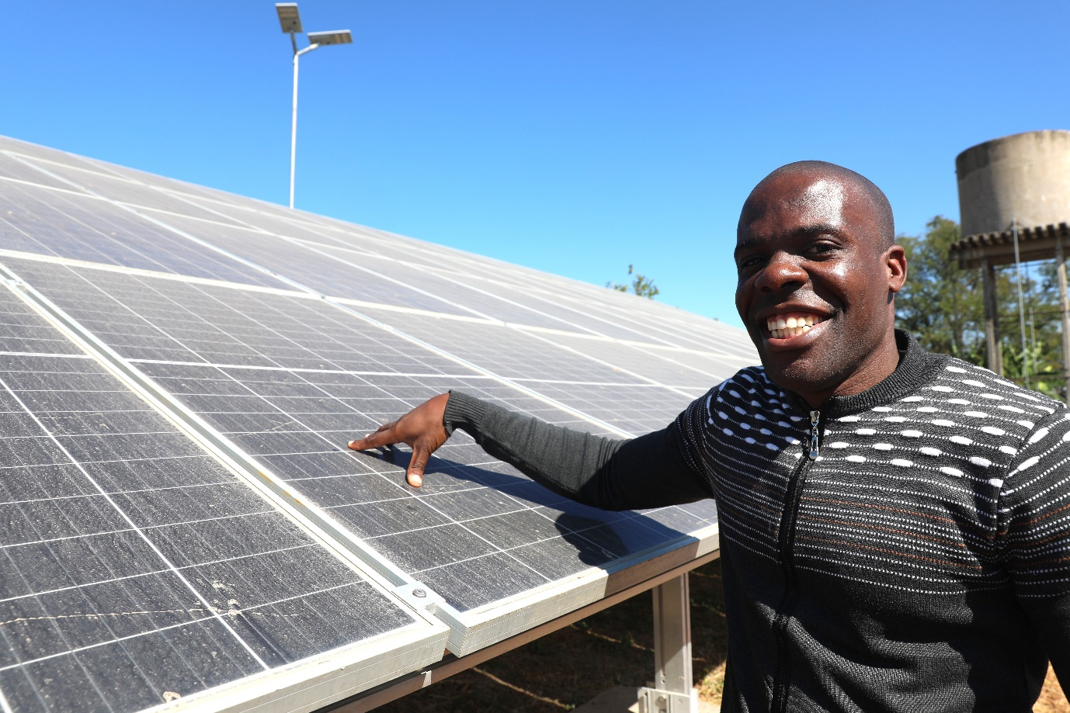

Support to #WeBelong Africa Young Key Populations Programme
In July 2023, the Communications Team supported a 3-day digital skills training workshop for young key populations (YKPs) hosted by UNDP and GALZ. The workshop equipped YKPs with skills to use digital tools to create and disseminate advocacy content safely and securely. The training was part of the #WeBelongAfrica Young Key Populations project which aims to increase the inclusion, participation, representation, and influence of YKPs in discussions, debates, and decision-making about laws, policies, and strategies that affect them. A range of topics including Campaign Framing, Effective Storytelling, Digital Security for YKP Advocates, Crisis Communications and Communicating Through “Owned” and Traditional Media were covered.



Support to drafting the NAC PrEP Communications Strategy
The Communications team supported the National AIDS Council (NAC) in drafting the Preexposure Prophylaxis (PrEP) Communication Strategy which is intended to provide guidance on developing innovative and effective communication strategies to promote lower risk behaviours and support diverse populations to make decisions that reduce their risk of HIV transmission by using PrEP. The strategy is a practical tool for selecting and locally adapting appropriate communication interventions to differing contexts and audiences in Zimbabwe. Through the strategy, the role of communications in demand generation for PrEP is articulated as well as the role they can play in breaking barriers to access of PrEP information for targeted populations.

Solar for Health Documentation for UNDP Global Climate Action Explained Video Series
From the unprecedented Solar for Health media tour which garnered substantial coverage across traditional and digital media platforms, the project was chosen to feature in a video series dubbed Climate Action Explained launched in 2024 (See Annex). The series explores what Climate Action looks like around the world and probes the need to scale up climate solutions for a secure and greener future. Zimbabwe is featured in this global series giving a spotlight to collaborative efforts between the Government and UNDP, exemplified by the Solar for Health initiative. Through support from the Global Fund, over 1,040 hospitals are now equipped with solar power, bolstering critical healthcare services amid climate-induced challenges. Video footage for the series were conducted in Masvingo Province at Chivi District Hospital, Nemwana Clinic, and Masvingo NatPharm Masvingo Warehouse with support from the Ministry of Health and Childcare.

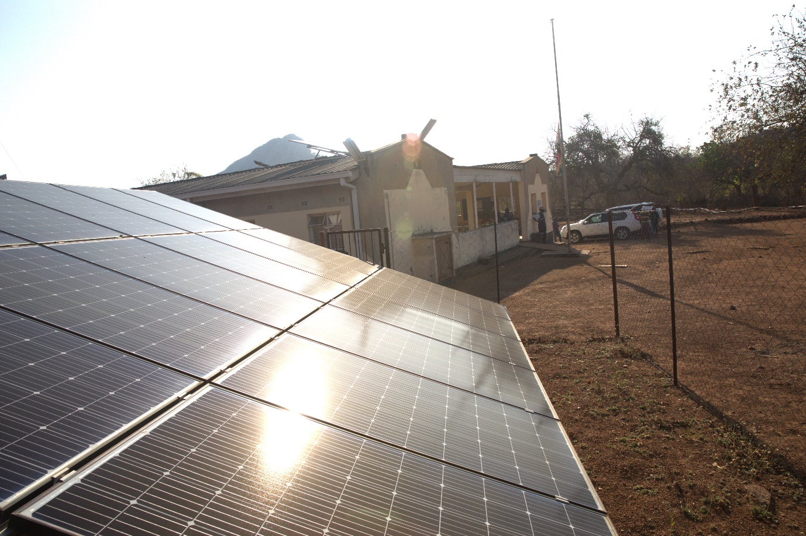

AGYW and OSC Field Mission
Communications team, in collaboration with the NAC, conducted a field visit to document impact stories and lessons learned from the implementation of DREAMS modified programme targeting the Adolescent Girls and Young Women (AGYW) in Chimanimani and Umguza districts. The field mission comprised the UNDP communications team, the NAC Communications team, 3 journalists and 2 multimedia consultants. The team worked collaboratively to raise awareness of AGYW interventions supported by the Global Fund among stakeholders including the government, development partners, policy makers and the public. Sustainable and Affordable Boarding Facilities at Ndima, Mhakwe, Mahlothova schools were toured as well as One-Stop Centres at Chimanimani Hospital and Nyamandlovu clinic. Substantial news stories in the mainstream media and online platforms were published from this tour as well as communication products including letters of hope from AGYW expressing how Global Fund interventions have changed their lives for the better and a documentary of the programme co-produced with NAC. A radio programme which was aired on the International Day of the Girl Child was also produced from this tour.

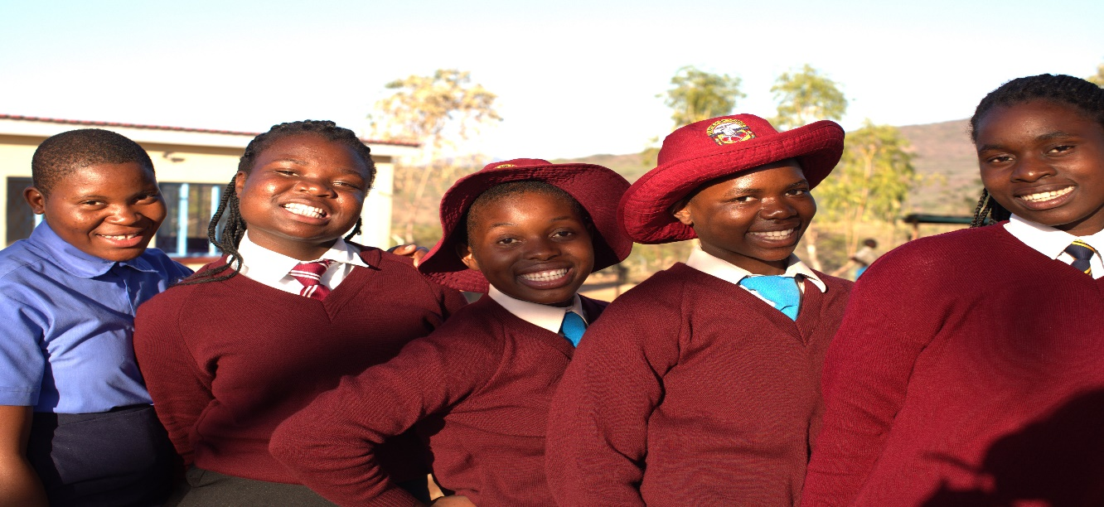
ICASA
The 22nd International Conference on AIDS and STIs in Africa (ICASA) 2023, held in Zimbabwe, served as a platform to amplify the UNDP and Global Fund partnership in Zimbabwe. The UNDP Communications team ran an exhibition throughout the conference and also had daily social media engagement that recorded significant national and international traction. Under the leadership of Zimbabwe's Ministry of Information, Publicity & Broadcasting Services and the National AIDS Council, UNDP Communications played a key role in supporting the drafting of Zimbabwe's ICASA's communication and visibility strategy, as part of a multistakeholder technical working group on the conference visibility and communication.

On the sidelines of ICASA, the Global Fund Executive Director Peter Sands, accompanied by UNDP Zimbabwe leadership, toured two project sites, and interacted with project beneficiaries, witnessing first-hand the transformative impact of the Global Fund HIV grant in Zimbabwe. The Executive Director toured the Medicines Control Authority of Zimbabwe (MCAZ) and the Mbare Hostels Clinic, run by the Centre for Sexual Health and HIV AIDS Research (CeSHHAR) Zimbabwe, which implements Zimbabwe's nationally scaled and sex worker-led Sex Work programme in partnership with the Ministry of Health and Child Care (MoHCC) and the National AIDS Council (NAC). The UNDP communication team interviewed the Executive Director on-site during the site visits and shared all audio-visual assets of the Executive Director's site visits with the Global Fund.
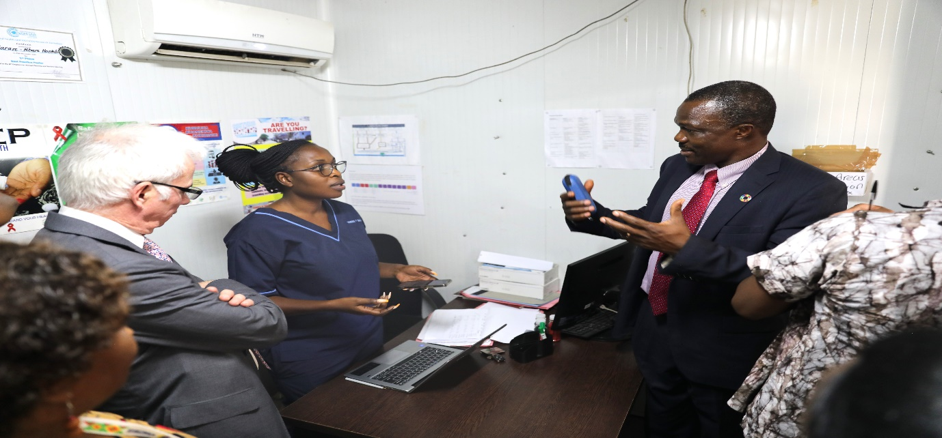
Communications focal persons at Headquarters.
At the recommendation of the Global Fund, a delegation from the Ministry of Health and National AIDS Council (Zambia), the Global Fund and the National AIDS Council in Zimbabwe visited a mining community in Goromonzi District (1 / 25 districts supported by the UNDP and Global Fund), to learn from Zimbabwe best practices in reducing HIV infections among young women. Photography from the site visit was also shared with the Global Fund for their use and archives.

At ICASA's pre–conference, UNDP joined the UN in Zimbabwe, under the leadership of UNICEF and WHO, for a High-Level Meeting on the Prevention of Mother-to-Child Transmission (PMTCT) and Elimination of New-born Infections in Africa. The high-level event reaffirmed the commitment of the African First Ladies and Governments towards an AIDS-free generation by presenting and promoting their roles in influencing political ownership, increasing sustainable domestic financing, and strengthening partnerships among governments, civil society, and development partners to end AIDS in children and mothers.

Communications support to PMU and Country Office material
Throughout the year, the Communications team offered support to the PMU and country office by laying out and designing factsheets, programme snapshots, project profiles and formatting of reports and presentations. The team also offered support with drafting talking points for management, photography and contributing to web and social media posts.

Key Challenges
- There were printing gaps for OI/ART attendance registers, PrEP registers, VMMC clint intake Forms and registers during the year resulting in improvision of these data collection tools.
- There were also data quality issues under and over reporting noted as a result of discrepancies of figures between reported data from Monthly Return Forms, data from source (registers) and DHIS2, which affected the data reported during the year.
- Inadequate Inventory Management Variances between stock on hand and physical stocks on visiting due to suboptimal use of eLMIS.
- The reduction in Programme Management cost by 10%, 20% and 20% by 2024, 2025 and 2026 respectively may affect timely grant activity implementation.
- Delays in getting monthly financial reports from the PR, for Malaria Covid19
- Delays in getting specifications and terms of reference for procurement and recruitment from the PR and SRs.
- The MoHCC has decentralised the payment processing to the provincial level, and this makes it difficult for FA to get supporting documents for some expenditures report.
- Delay in submission of design, drawings & BOQ for infrastructure projects affected timely initiation and completion of most projects.
- The delay in the approval of disposal of expired medicines resulted in accumulation and taking storage spaces at NatPharm Warehouses.
- Although not unique to the reporting period, stigma and the restrictive operating environment is still a barrier to service delivery for the KPs in their diversity. There is still a lot of stigma especially within the family and community settings, which keeps the KPs away from services hence the poor performance of some of the KP indicators.
- The PWUID programme failed to take off due to delay in selection of SRs and lack of expertise on how to programme for the beneficiaries.

Success Stories
Creating opportunities for Young women who sell sex (YWSS) in the Programme

Modified Dreams success story: Empowering AGYW through SRHR sessions

In Umzingwane district many girls are faced with the challenge of dropping out of school due to a number of factors which include lack of parental support on education, artisanal miners preying on the girls and lack of proper guidance for the girls to focus on their education. The introduction of the DREAMS Modified project in 2018 was a welcome development and a relief for many AGYW in the district. Through the project’s Parent Child Communication component many AGYW have found solace and a platform where they can be empowered and encouraged to make decisions that are bold and wise about their SRHR issues. Parents and their adolescents are now able to discuss issues that often were considered as taboo in the past. A group of AGYW that attended PCC sessions during Q12 were appreciative of the program and hoped that the program may continue being implemented as it has empowered many girls in their ward. One of the AGYW had this to say: “I would like to thank the funders of the project for identifying issues we face as girls in the communities. Most of the times as girls we do not have ample time to openly discuss about challenges that we face with our parents. I am glad that I was part of the girls that were recruited to attend the sessions during this period. Now I feel very empowered and courageous to talk to my grandmother about education, sexual and gender-based violence, relationships and other issues. My grandmother has also been open to me and we have a friendly and honest relationship. This has also helped in molding me and ensuring that I do not get carried away but rather to stay put on my education. I have the ability to state how I feel at a particular moment. Thank you DREAMS project for the assistance you are rendering to us as girls and our parents.”
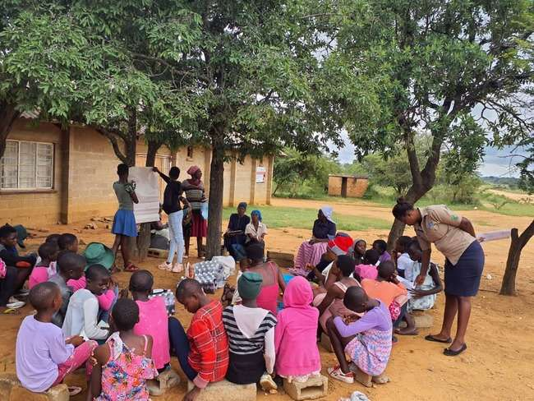
AGYW attending a PCC session
Male engagement program success story
In Rushinga district a club member who tested positive in one of the male engagement clubs went for couple testing at the local health facility and the wife who was pregnant also tested positive and were referred further for ART and they are now on treatment and monitoring for Pre-Natal is being done at Mukonde Clinic. This is a success as the country aims towards eliminating pediatric HIV by 2030.

Annex 1 Key Performance Indicators
Annex 1.1: Impact and Outcome Indicators
Indicator | Target | Year | Due Date for Reporting | Result |  |  |  | Comments on (a) results achieved, (b) data sources, and (c) any other contextual information
 |  |  |  | Numerator (#) | Denominator (#) | Percentage (%) | Year
HIV I-6 Estimated percentage of children newly infected with HIV from mother-to-child transmission among women living with HIV delivering in the past 12 months | 6.08% | 2022 | 30-Jun-23 | 4,200 | 51,845 | 8.10 | 2022 | The national program aimed to reduce percentage of children newly infected with HIV from mother-to-child transmission among women living with HIV delivering in the past 12 month to 6.08% in 2022.  The program failed to meet its target. by 2.02%. The factors attributed to failure to reach the target are as follows:  a) pregnant women who were not retained in care at delivery,  b) those who did not receive maternal ART and incident infections (sero-convections) from both pregnant and lactating women.  PMTCT transmission rate trend shows an increase from 7.57% in 2019, 7.90% in 2020 and 8.43% in 2021. It declined slightly to 8.10% in 2022.
HIV I-4 Number of AIDS-related deaths per 100,000 population | 113 | 2022 | 30-Jun-23 | 120.7 |  |  | 2022 | Results derived from data from the 2022 HIV Estimates shows that 120.72 /100,000 AIDS-related deaths were experienced during the year 2022 (20,465/17,157,840*100,000).  A declining trend in AIDS-related deaths has been observed from 162.62 per 100,000 population in 2018, 150.39/100,000 in 2019, 141.86/1000,000 in 2020 and 126.24 in 2021 and 120.72 in 2022.  The program did not meet the target by 7.72. This could be due to development of advanced HIV disease (AHD) among some patients in care.
HIV I-14 Number of new HIV infections per 1000 uninfected population | 1.07 | 2022 | 3O Jun 2022 | 1.11 |  |  | 2022 | The results provide achievement on the direction of the HIV epidemics in Zimbabwe and reflects the impact of HIV prevention and treatment. The national program aimed to reduce the number of people newly infected by the HIV virus to 1.11per 1000 uninfected population.  The results indicate that there were an estimated 17,337 new infections resulting into 1.11 new HIV infections per 1,000 uninfected populations against a target of 1.07.  The reported result has not been achieved by 0.04 and may be attributed to:  a) the possibility of disparities in uptake of ART among some risky population groups such as men, adolescents, young people, and key populations  b) continued new infections among some risk population such as Men having Sex with Men (MSM), Sex Workers and transgender.  c) leakages in the HTS and treatment cascade.
HIV O-13 Proportion of ever-married or partnered women aged 15-49 who experienced physical or sexual violence from a male intimate partner in the past 12 months | 17% | 2021 | 14-Aug-22 |  |  |  | 2022 | The indicator is tracked by Multi-indicator Survey (MICS), Zimbabwe Demographic Health Survey or the or ZIMPHIA. The last ZIMPHIA was carried out in 2020 and the other two Population based surveys have not been carried out. The country was planning to carry out ZDHS in 2023 but the exercise coincides with the Country's elections. It is likely that the survey will be carried out after the elections in September 2023
HIV O-11⁽ᴹ⁾ Percentage of people living with HIV who know their HIV status at the end of the reporting period | 93% | 2022 | 1-Mar-23 | 1,248,772 | 1,310,438 | 95.3 | 2022 | The program acknowledges that the most effective way to ensure that people living with HIV are aware of their HIV status is to continue offering HIV testing services (HTS) at locations and among populations with the highest HIV burden. HTS is the entry point to the continuum of care as it measures the progress towards increasing proportion of people living with HIV who know their HIV status. The national program aimed to increase knowledge of HIV status to 93% in 2022. The reported result for the indicator has been generated from the 2022 National HIV Estimates using UNAIDS Spectrum Data. The results indicate that there were an estimated 95% (1,248,772/1,310,438) of people who know their HIV status. This could be attributed to targeted testing, index case testing and contact tracing.
HIV O-12 Percentage of people living with HIV and on ART who are virologically suppressed | 93% | 2022 | 1-Mar-23 | 951,733 | 1,001,472 | 95.0 | 2022 | The result shows the effectiveness of ART programme which includes quality of care as an early warning indicator for development of HIV Drug Resistance (HIV DR). In 2022, the percentage of people living with HIV and on ART who are virologically suppressed was 95% (951,733/1,001,472) surpassing the set target of 94 % by 1%.  This performance shows a 1.3%-point increase when compared to 93.7% (795,282/848,648) achieved in 2021.
HIV O-21 Percentage of people living with HIV not on ART at the end of the reporting period among people living with HIV who were either on ART at the end of the last reporting period or newly initiated on ART during the reporting period | 8% | 2022 | 1-Mar-23 | 29,710 | 1,263,329 | 2.4 | 2022 | During the reporting period an analysis of 1,233,619 patients who were on treatment as at end of 2022 was done. The results show a total attrition of 2.35% (29,710/ 1,263,329) against an acceptable threshold of 5% at the end of December 2022 as per the new 2023 GF indicators definition of the indicator. This performance shows an improvement by 14.15% points increase when compared to 16.5% (33,243/201,022) achieved at the end of December 2021.
HIV O-13 Proportion of ever-married or partnered women aged 15-49 who experienced physical or sexual violence from a male intimate partner in the past 12 months | 17% | 2021 | 14-Aug-22 |  |  |  | 2023 | The MIC survey has not yet been carried out at the national level and data is not yet available for reporting.
HIV O-20 Percentage of females aged 15-24 who dropped out of school in the last year | 0.79% | 2023 | 14-Feb-24 | 708 | 15,147 | 4,67 | 2023 | "The indicator measures progress made in retaining young girls 15-24 years in school through supported interventions. The project’s target was to reduce dropouts to at least 0.79% 200/25191 ) by Dec 2023. The result shows that 4.67% (708/15147) girls dropouts out of school. The indicator failed to reach the target by 3.88%. The failure to achieve the target may be attributed to reasons provided below. The performance of dropout rate indicator has been a challenge as can be noted from the increasing trend which shows that 1.19% (2020), 2.1% (2021), 2.17% (2022), 4.67% (2023). To address the increasing dropout rates the programme developed a strategy focusing on early warning system that will help in monitoring & mitigating dropout included and budget approved in GC7. Pregnancy and marriage were the major reasons for dropouts with as high numbers as 186 and 295 respectively. Lack of interest had high figures also amounting to 42. Chimanimani district had the highest number of marriages, that is 202 followed by Kwekwe with 190 AGYW.
HIV O-11⁽ᴹ⁾ Percentage of people living with HIV who know their HIV status at the end of the reporting period | 94% | 2023 | 14-Feb-24 |  |  |  | 2023 | The consolidation data from the spectrum estimates will only be available in May/June 2023 this indicator will be reported in Sem 1 of 2024. The PR reported the Sem 4 results for the same impact and outcome indicator in Sem 5 due to the same reason.
HIV O-12 Percentage of people living with HIV and on ART who are virologically suppressed | 94% | 2023 | 14-Feb-24 | 1,016,651 | 1,061,333 | 95.8 | 2023 | The result shows the effectiveness of ART programme which includes quality of care as an early warning indicator for development of HIV Drug Resistance (HIV DR). In 2023, the percentage of people living with HIV and on ART who are virologically suppressed was 95.79% (1,016,651/1,061,333) against a target of 94.00%. This performance shows 0.76% points increase when compared to 95.03% (951,733/1,001,472) achieved in 2022.  VLS among children aged 0-14 years was 88.47% (31,482 /35,584), with a higher performance among female children 89.13% (16,869/18,926) than male children 87.72% (14,613/16,658). Low performance among children could be attributed to poor ART adherence.  A VLS of 95.52% (38,393/40,193) was recorded for PLHIV on ART with an unknown age and sex which was excluded from age/sex disaggregation analysis. Data quality improvement initiations will be done to improve completeness within laboratory information management systems.  Adults: 96.07% (946,776/985,556)  Children: 88.47% (31,482 /35,584) .
HIV O-21 Percentage of people living with HIV not on ART at the end of the reporting period among people living with HIV who were either on ART at the end of the last reporting period or newly initiated on ART during the reporting period | 7% | 2023 | 14-Feb-24 | 71,496 | 1,305,430 | 5.5 | 2023 | Total attrition was 5.48% against set target of 7% at the end of December 2023 which achieved the set target for the reporting period. The reported results for the indicator show an achievement ratio of 127.7% (7.00%/5.48%) at the end of December 2023. There was 212.73% points increase in terms of the achievement ratio at the end of December 2023, [127.7% (7.00%/5.48%)] and at the end of December 2022 [340.43% (8.00%/2.35%)]. Meeting the target could be attributed retention initiatives including defaulter tracking, optimized regimens, enhanced adherence counselling, etc.  However there is an increase in attrition as compared to the 2.35% (29,710/1,263,329) achievement at the end of December 2022.  Total attrition among adults aged 15 + years was 4.92%, with female adults (3.32%) having a lower attrition rate than males (7.84%). Total attrition among children was 18.32% in 2023. This could be an overestimate as children transition to the older age group and fewer of them enter the age group due to PMTCT gains.

Annex 1.2: Impact and Outcome Indicators
Indicators | Sem 5 Result |  |  | Sem 6 Result |  | % annual target | annual result | annual result | annual result | achievement ratio
Indicators | Numerator (#) | Denominator (#) | Numerator (#) |  | Denominator (#) |  | Numerator (#) | Denominator (#) | annual result | achievement ratio
KP-1a⁽ᴹ⁾ Percentage of men who have sex with men reached with HIV prevention programs - defined package of services | 4,918 | 23,326 | 6,311 |  | 23,326 | 38.0 | 11,229 | 23,326 | 48.1 | 126.7
KP-1c⁽ᴹ⁾ Percentage of sex workers reached with HIV prevention programs - defined package of services | 17,446 | 45,000 | 17,187 |  | 45,000 | 56.0 | 34,633 | 45,000 | 77.0 | 137.4
KP-6a Percentage of eligible men who have sex with men who initiated oral antiretroviral PrEP during the reporting period | 634 | 9,202 | 844 |  | 9,202 | 18.0 | 1,478 | 18,404 | 8.0 | 44.6
KP-6c Percentage of eligible sex workers who initiated oral antiretroviral PrEP during the reporting period | 4,595 | 13,005 | 4,119 |  | 13,005 | 50.0 | 8,714 | 26,010 | 33.5 | 67.0
HTS-2 Number of adolescent girls and young women who were tested for HIV and received their results during the reporting period | 6,027 | 6,375 | 5,445 |  | 6,375 | 100.0 | 11,472 | 12,750 | 90.0 | 90.0
HTS-3a⁽ᴹ⁾ Percentage of men who have sex with men that have received an HIV test during the reporting period and know their results | 1,043 | 18,404 | 1,417 |  | 18,404 | 17.0 | 2,460 | 18,404 | 13.4 | 78.6
HTS-3c⁽ᴹ⁾ Percentage of sex workers that have received an HIV test during the reporting period and know their results | 12,288 | 26,010 | 12,569 |  | 26,010 | 60.0 | 38,298 | 26,010 | 147.2 | 245.4
HTS-4 Percentage of HIV-positive results among the total HIV tests performed during the reporting period | 39,446 | 783,574 | 38,249 |  | 788,045 | 10.0 | 77,695 | 1,571,619 | 4.9 | 49.4
HTS-5 Percentage of people newly diagnosed with HIV initiated on ART | 36,976 | 39,446 | 34,017 |  | 38,249 | 95.0 | 70,993 | 77,695 | 91.4 | 96.2
PMTCT-2.1 Percentage of HIV-positive women who received ART during pregnancy and/or labour and delivery | 22,055 | 51,845 | 20,211 |  | 51,845 | 95.0 | 20,429 | 51,846 | 39.4 | 41.5
PMTCT-3.1 Percentage of HIV-exposed infants receiving a virological test for HIV within 2 months of birth | 20,429 | 25,923 | 21,840 |  | 25,923 | 85.0 | 42,269 | 51,846 | 81.5 | 95.9
TCS-1b⁽ᴹ⁾ Percentage of adults (15 and above) on ART among all adults living with HIV at the end of the reporting period | 1,198,517 | 1,235,851 | 1,189,793 |  | 1,235,851 | 94.0 | 1,189,793 | 1,235,851 | 96.3 | 102.4
TCS-1c⁽ᴹ⁾ Percentage of children (under 15) on ART among all children living with HIV at the end of the reporting period | 47,664 | 74,587 | 44,141 |  | 74,587 | 78.2 | 44,141 | 74,587 | 59.2 | 75.7
TB/HIV-7 Percentage of PLHIV on ART who initiated TB preventive therapy among those eligible during the reporting period | 126,154 | 175,003 | 95,227 |  | 147,274 | 80.0 | 221,381 | 322,277 | 68.7 | 85.9
M&E-2a Completeness of facility reporting: Percentage of expected facility monthly reports (for the reporting period) that are actually received | 10,452 | 10,764 | 10,526 |  | 10,764 | 90.0 | 20,978 | 21,528 | 97.4 | 108.3
PSM-3 Percentage of health facilities providing diagnostic services with tracer items available on the day of the visit or day of reporting |  |  | 1,777 |  | 1,850 | 97 | 1,777 | 1,850 | 96.1 | 99.0
PSM-4 Percentage of health facilities with tracer medicines for the three diseases available on the day of the visit or day of reporting |  |  | 1,726 |  | 1,727 | 98 | 1,726 | 1,727 | 99.9 | 102.0
PSM-7 Percentage of health product batches for the three diseases tested for quality in line with Global Fund Quality Assurance policy |  |  | 99 |  | 120 | 100 | 99 | 120 | 82.5 | 82.5
HRH-1 Vacancy rate: Number of full-time posts unfilled for at least 6 months as a percentage of total number of funded posts |  |  | 2,137 |  | 31,571 | 6.0 | 2,137 | 31,571 | 6.8 | 88.6
YP-2 Percentage of adolescent girls and young women reached with HIV prevention programs- defined package of services |  |  | 14,855 |  | 14,970 | 100 | 14,855 | 14,970 | 99.2 | 100.8

Annex 2: Summary of assets by SR (in value and category) 2023
SR | Category | Quantity | Purchase value (USD)
BRTI | IT Equip | 112 | 30,447.78
 | Motorbikes | 127 | 231,857.00
 | Motor Vehicles | 9 | 784,861.78
BRTI Total |  | 248 | 1,047,166.56
FACT | Furniture | 68 | 31064.95
 | IT Equip | 347 | 97,503.00
 | Motor Vehicle | 9 | 331,061.13
 |  | 424 | 459,629.08
HSC | Comms Equip | 1 | 1,144.00
 | IT Equip | 101 | 53,030.93
 | Motor Vehicle | 5 | 129,773.60
 |  | 107 | 183,948.53
MCAZ | Lab Equip | 6 | 15,700.58
 | IT Equip | 9 | 11,306.13
 | Medical Equip | 119 | 613,020.32
 | Motor Vehicle | 1 | 25,354.70
 |  | 135 | 665,381.73
MOHCC | Lab Equip | 628 | 994,270.27
 | Furniture | 4 | 599,000.00
 | IT Equip | 2999 | 2,665,519.63
 | Motorbikes | 137 | 341,263.79
 | Medical Equip | 226 | 2,158,268.99
 | Motor Vehicle | 106 | 3,249,050.25
 |  | 4100 | 10,007,372.92
NAC | Comms Equip | 1 | 1,403.45
 | Furniture | 112 | 43,048.80
 | IT Equip | 676 | 290,892.03
 | Motor Vehicle | 64 | 2,242,904.99
 |  | 853 | 2,578,249.27
NATPHARM | Buildings - Temporary and Mobile | 1 | 40,750.01
 | Comms Equip | 26 | 29,358.00
 | IT Equip | 4 | 8,153.72
 | Motor Vehicle | 15 | 762,354.76
 | Office Equip | 3 | 14,977.00
 | Transportation Equip | 2 | 167,693.00
 |  | 51 | 1,023,286.49
Grand Total |  | 5918 | 15,965,034.58

Annex 2: Published Communication stories
Adolescent Girls and Young Women (AGYW) Stories
Star FM News at 2pm in English on Boarding Facilities.mp3
Star FM News at 7pm in Shona on Boarding Facilities.mp3
UNDP Facilitates Construction of Low Cost Boarding Facilities To Reduce HIV Vulnerability In Adolescent School Girls
One Stop Centres as Key Accelerators Towards Zimbabwe’s Progress To End AIDS By 2030
StarFM News at 2pm on One Stop Centres.mp3
StarFM News at 7pm in Shona on One Stop Centres.mp3
Day Of The Girl Child Radio Programme Special (Radio Zimbabwe).MP3
Dreams project uplifts disadvantaged girls

Solar For Health Stories
ZTV News
Shona News Bulletin – NatPharm Masvingo - 07 June 2023 (from 17 minutes)
Main News Bulletin at 8pm - NatPharm Masvingo - 07 June 2023 (from 11 minutes)
Shona News Bulletin – Electronic Health Records - 08 June 2023 (from 5 minutes)
Main News Bulletin at 8pm - Electronic Health Records - 08 June 2023 (from 17 minutes)
Weekend Edition News – S4H improves vaccine programme 10 June 2023
Main News Bulletin at 8pm - Solar Powered Solutions for rural communities (from 16 minutes)

THE HERALD
Communities take lead in safeguarding health infrastructure
Solar for Health project powers NatPharm warehouse
Major boost for immunisation programme
Roll out of EHR gains momentum

NEWSDAY
UNDP Powers 1000 rural clinics
Chivi District Medical Officer giving an overview of the benefits of the Solar for Health project in his district

SABC CHANNEL AFRICA RADIO
SABC Channel Africa News in Chichewa
SABC Channel Africa News in English

STAR FM RADIO NEWS
Star FM News Report on Solar for Health
Star FM News Report with Emmanuel Boadi
Major boost for rural facilities’ immunisation programme
UNDP-Global Fund invests 20 million US in Zim Solar4Health project

RADIO ZIMBABWE
Nyaya dzeUtano - Radio Zimbabwe Programme

CONSERVE ZIM
Zim hospitals powered up through Global Fund S4H
UNDP’s solar project improve drug storage in Zimbabwe

HEALTH TIMES
Bye-bye candlelight births: Rural women cherish Undp Global Fund solar electrification project
Solar for health project boosts pharmaceutical cold-chain capacity in Masvingo
Zimbabwe’s Health Sector Goes Green with Solar Powered Electronic Health Records

STORIES ON UNDP WEBSITE
22 Letters of Hope by UNDP Zimbabwe
Factsheet: Towards Ending AIDS as a Public Health Threat by 2030 | United Nations Development Programme (undp.org)
Future-proofing labs to save lives in Zimbabwe | United Nations Development Programme (undp.org)
Scaling access to innovations for HIV prevention | by UN Development Programme | Medium

SOCIAL MEDIA POSTS

UNDP X ACCOUNT

Tweets from ICASA 2023
With support from @UNDP @GlobalFund @MCAZofficial labs contribute to ending AIDS in Zimbabwe

With support from the @UNDP @Global Fund partnership, laboratories at @MCAZofficial are contributing to collective efforts to #EndAIDS in Zimbabwe

With support from the @UND @GlobalFund partnership, laboratories at @MCAZofficial
are contributing to collective efforts to #EndAIDS

South-South learning in action at #ICASA2023! A delegation from @mohzambia, National AIDS Council 🇿🇲, & a @GlobalFund team visits a mine in Goromonzi

"Community leadership is central to the HIV and AIDS response."Our conversation with @GlobalFund Executive Director @PeterASands on the sidelines of #ICASA2023

#ForEveryChild living with HIV, sustainable financing. 💰

Is it possible to #ENDAIDS by 2030? Our Resident Representative Dr. @AyodeleOdusola
believes it is!

Toured the @MCAZofficial labs with @PeterASands today. Witnessed firsthand the transformative impact of @GlobalFund investments

On the sidelines of #ICASA2023, we had the privilege to accompany Global Fund ED
@PeterASands to MCAZ 🇿🇼

One of the most important biennial gatherings is taking place in Harare, Zimbabwe.
@UNDP is present at the weeklong deliberations - ready to accelerate and sustain progress to #ENDAIDS by 2030

Inspiring 2️⃣2️⃣ voices of a shared dream: to #EndAIDS for everyone by 2030.

Inclusion drives results!
An insightful discussion on adolescent girls & young women meaningful engagement & leadership in the @GlobalFund Grant Cycle 7.

With the science & 💊 we have, no baby should be born with HIV ~ ED
@UNAIDS, @Winnie_ByanyimaHappening now 🗓 A pre @icasa2023 @OAFLAD #HLM on Prevention of Mother-to-Child Transmission & elimination of new - born infections in Africa.

Ending AIDS is possible when we #LetCommunitiesLead!

In solidarity with People Living with HIV and in honour of millions of lives lost to AIDS, we joined partners and communities working to advance the HIV response in Zimbabwe 🇿🇼 for a candlelight memorial ahead of #WorldAIDSDay.

UNDP Facilitates Construction of Low Cost Boarding Facilities To Reduce HIV Vulnerability In Adolescent School Girls...Read Here

Social Media Posts on Solar for Health

MoHCC
NatPharm benefited from Solar For Health project
Solar powered refrigerators allow safe storage of vaccines

Star FM News
S4H enhances the quality of health services in rural facilities.
S4H for optimum storage of vaccines
Uninterrupted power supply for waiting mothers
Byo City Health Chief Nursing Officer on importance of security of the solar system.
NatPharm solar ensures cold storage of vaccines
Major boost for rural facilities’ immunisation programme
UNDP-Global Fund invests 20 million US in Zim Solar4Health project

Health Times
Solar for Health Project Boosts Pharmaceutical Cold Chain Capacity in Masvingo
Solar For Health project has improved the quality of care in our facilities
Health Journalists on a media tour to assess progress and impact of Solar for Health
Bye-bye candlelight births
Zimbabwe’s Health Sector Goes Green with Solar Powered Electronic Health Records
The Dispensary Assistant at Palandaba Clinic displays how the Electronic Health Records system works
The S4H project has not been spared by vandalism and robberies
S4H project has improved capacity in the EPI department
S4H reduced their electricity bill
So far 100 Health facilities have benefited from the solar in Masvingo

Conserve Zim
Byo Chief Nursing Officer, makes some indications to the touring media team
Byo City Health Director says the #SolarForHealthmproved maternal health
Journalists interviewing Phillip Maphosa. Community Health Nurse at Mawabeni Clinic
S4H is assisting in covering vaccination gaps
A lab technician at Chivi District Hospital demonstrates her work in a Solar powered lab

The Herald
Communities take lead in safeguarding health infrastructure

NEWSDAY
Chivi District Medical Officer giving an overview of the benefits of the Solar for Health project in his district
UNDP powers 1 000 rural clinics

Vision 2030
UNDP working in line with government policy

